Name

Mathematics Advanced Year 11
Introduction to Functions

Book 1 |  | Version: 261007  Feedback:  https://MrDingMaths.com
Contents
Syllabus Content 2
Relations 3
Functions 7
Function Notation 9
Vertical Line Test 19
Function Notation and Graphs 22
Zeroes and $f$(0) 25
Interval Notation 26
Domain and Range 28
Natural Domain and Range 34

Syllabus Content
MAV-11-02 uses functions and relations to model, analyse and solve problems
introduction to functions and relations
- Describe a relation between two sets as an association between the elements of one set and the elements of the other set
- Define a real function $f$ of a real variable $x$ as a relation where each element $x$ of a given set is associated with exactly one element $y$ of the second set
- Recognise that a relation is a rule which can be represented by an algebraic formula, a table of values, a set of ordered pairs $\left(x,y\right)$ or a graph
- Use the notation $f\left(x\right)$ to identify the unique value of $y$ associated with $x$ when working with functions, and refer to it as the value of $f$ at $x$
- Refer to $x$ in a function $y=f(x)$ as the independent variable of the function, and refer to $y$ as the dependent variable
- Substitute numeric and algebraic expressions into the formulas of functions
- Apply the vertical line test on the graph of a relation to determine whether it represents a function
- Define the domain of a function $f$ as the set of real numbers on which $f$ is defined
- Define the range of a function $f$ as the set of values of $f(x)$ obtained as $x$ varies over the domain of $f$
- Refer to a value in the domain of a function at which the function is 0 as a zero of the function
- Recognise that the $x$-intercepts of the graph of $y=f\left(x\right)$ are its zeroes, the solutions of $f\left(x\right)=0$, and that the $y$-intercept is $f\left(0\right)$

Relations

- Relations
A relation, $R$, from set $X$ to set $Y$ is a collection of ordered pairs $\left(x,y\right)$ where the first coordinate comes from $X$ and the second coordinate comes from $Y$.
In other words, there is a relationship between the two sets.
We can say that $R$ ‘maps’ elements of set $X$ to set $Y:$ $R: x↦y$.
- In set notation, $X$ refers to the entire set, while $x$ refers to individual elements in $X$.

- Identify Relations
Let $X=\left\{1,3\right\}$
$Y=\left\{p,q,r\right\}$
✖  $$\left\{ \left(1,p\right), \left(4,q\right) \right\}$$ | ✔  $$\left\{ \left(1,p\right), \left(3,q\right) \right\}$$ |  | ✔  $$\left\{ \left(1,r\right) \right\}$$ | ✔  $$\left\{ \left(3,p\right), \left(3,r\right) \right\}$$ |  | ✖  $$\left\{ \left(1,p\right), \left(q,3\right) \right\}$$
Using the sets $X$ and $Y$ above, decide if the set of ordered pairs are a relation from $X$ to $Y$.
- $\left\{ \left(1,q\right), \left(3,p\right) \right\}$ |  | - $\left\{ \left(1,p\right), \left(1,r\right), \left(3,q\right) \right\}$ |  |  | - $\left\{ \left(3,p\right), \left(2,q\right) \right\}$
- $\left\{ \left(p,1\right) \right\}$ |  | - $\left\{ \left(3,r\right) \right\}$ |  |  | - $\left\{ \left(1,3\right) \right\}$

- Representing Relations
We can represent relations using:
- A set of ordered pairs.
- A table of values.
- An arrow diagram.

- Interpret Relation representations
Consider $R=\{ \left(a,1\right), \left(b,3\right), \left(d,2\right), \left(d,3\right) \}$, where $x↦y$.
We can represent this as a table and an arrow diagram:
 | $X$ $Y$  $$1$$  $$2$$  $$3$$  $$a$$  $$b$$  $$d$$
  $$x$$ | $$a$$ | $$b$$ | $$d$$ | $$d$$
  $$y$$ | $$1$$ | $$3$$ | $$2$$ | $$3$$
Represent using a table of values and arrow diagram:
- $\left\{\left(a,1\right),\left(b,2\right),\left(d,1\right),\left(d,2\right)\right\}$

- $\left\{ \left(1,5\right), \left(1,6\right), \left(3,3\right), \left(8,4\right) \right\}$

- $\left\{ \left(7,1\right), \left(7,2\right), \left(3,1\right), \left(2,7\right), \left(14,3\right), \left(6,2\right)\right\}$

- Real Relations
A relation is real when the elements of the two sets are real numbers $R$.
The connection between the two sets can be arbitrary, or it can be according to some rule.

Relation between students and languages: Not a real relation.
Relation between student heights and masses: A real relation.
Relation between an integer $x$ and $y=x^{2}$: A real relation.

Real relations are important to this course because they can be graphed on the Cartesian plane, and therefore their behaviour and properties can be easily noticed.

- Investigation Real relations
Consider: $R:\left\{\left(x,y\right) where x,y∈R and y=x+1\right\}$
This means:
There is a ……………… from set …… to set ……, where the elements of both sets are ……… numbers, and where the elements are related by the rule ……………
Complete the table of values representing this relation:
$$x$$ | $$-1$$ | $$0$$ | $$1$$ | $$2$$ | $$\frac{1}{3}$$ | $$π$$ | $$p$$
$$y$$

Sketch the relation on the Cartesian plane.
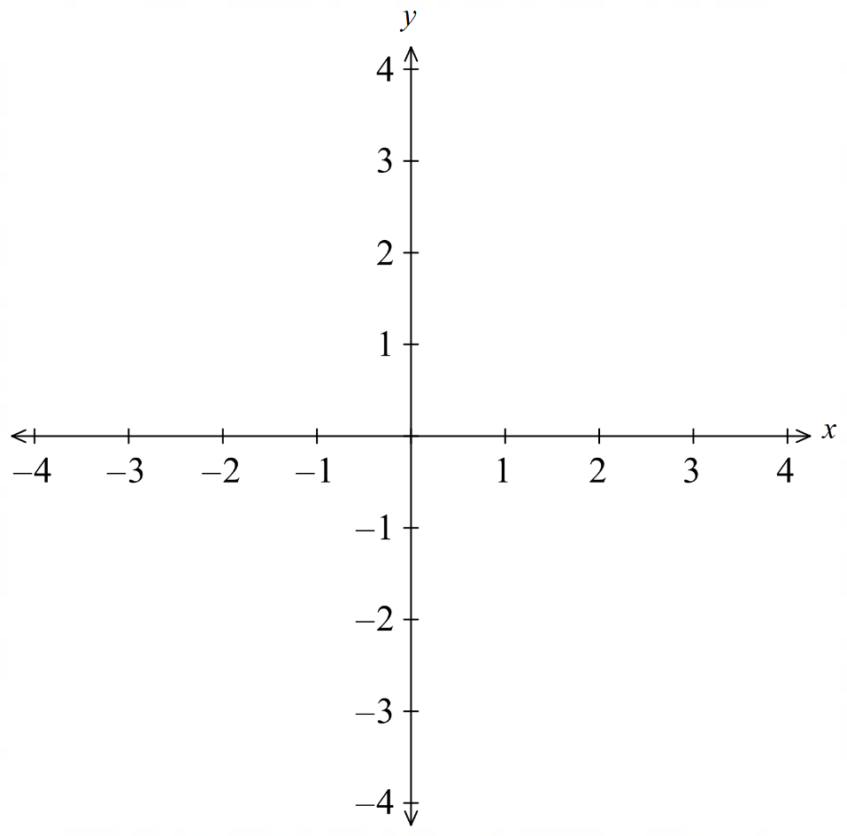
Since the entire course is concerned with real relations, we can assume that $x,y∈R$ for all relations from now on and simply state the rule.
$R:\left\{\left(x,y\right) where x,y∈R and y=x+1\right\}$becomes $y=x+1$

Foundation
- $A=\{1,3,5\}, B=\{p,q,r\}.$
For each set of ordered pairs, state whether it is a relation from $A$ to $B$.
If not, identify the first invalid ordered pair.
  - $\{(1,p),(3,q),(5,r)\}$
Yes
  - $\{(1,p),(3,q)\}$
Yes
  - $\{(1,p),(1,q),(5,r)\}$
Yes
  - $\{(1,p),(3,q),(4,r)\}$
No, (4,𝑟)
  - $\{(1,p),(3,s),(5,r)\}$
No, (3,𝑠)
  - $\{(1,p),(q,3),(5,r)\}$
No, (𝑞,3)
  - $\{(5,p)\}$
Yes

- $A=\left\{1,2,4\right\}, B=\left\{1,3,5,6\right\}.$
List every ordered pair $(a,b)$ satisfying the rule.
- $b>a$  $$\{(1,3),(1,5),(1,6),(2,3),(2,5),(2,6),(4,5),(4,6)\}$$ | - $b>a+1$  $$\{(1,3),(1,5),(1,6),(2,5),(2,6),(4,6)\}$$ | - $b>a+2$  $$\{(1,5),(1,6),(2,5),(2,6)\}$$
- $b<a$  $$\{(2,1),(4,1),(4,3)\}$$ | - $b≤a$  $$\{(1,1),(2,1),(4,1),(4,3)\}$$ | - $b=2a-1$  $$\{(1,1),(2,3)\}$$

- Write each relation as a set of ordered pairs.
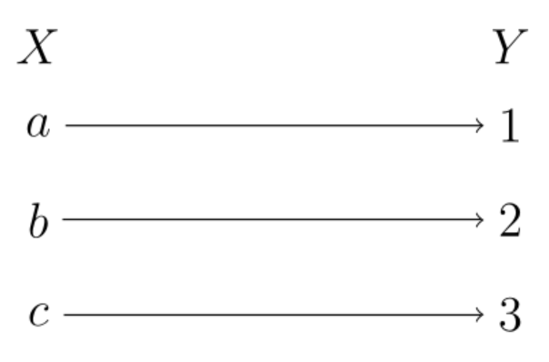  $$\{\left(a,1\right), \left(b,2\right), \left(c,3\right)\}$$ | 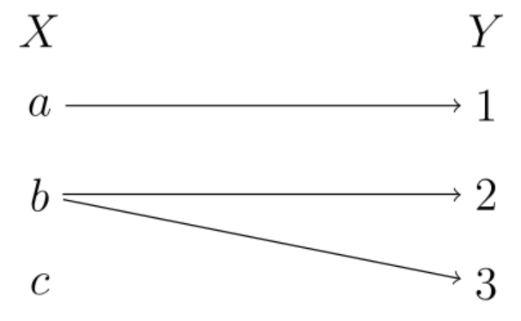  $$\{\left(a,1\right), \left(b,2\right), \left(b,3\right)\}$$ | 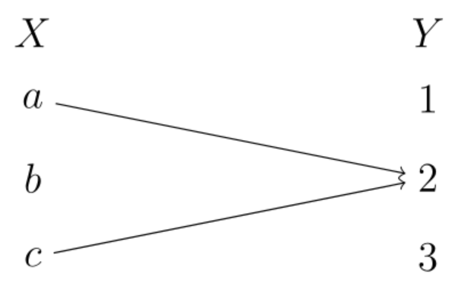  $$\{\left(a,2\right), \left(c,2\right)\}$$

Functions

- Relations and Functions
A relation $R$ connects elements from one set to a second set.  $$\left(1,5\right), \left(1,6\right), \left(3,3\right), \left(8,4\right)$$ | A function $f$ is a special relation where each  $x$-value has only one $y$-value.  (only one arrow leaving each $x$ value)  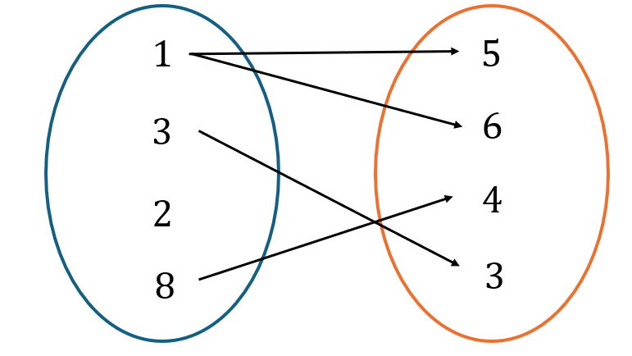  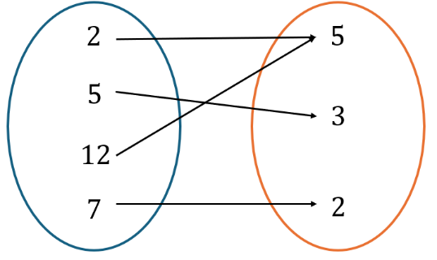  $$\left(2,5\right), \left(5,3\right), \left(12,5\right), \left(7,2\right)$$

- Identify whether a relation is a function
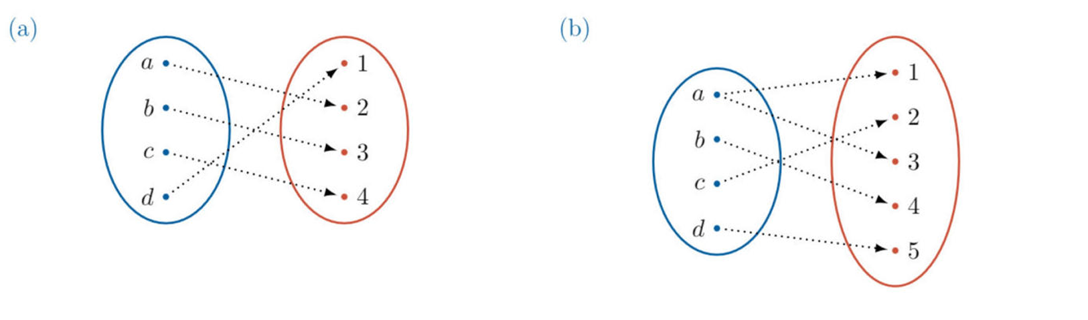

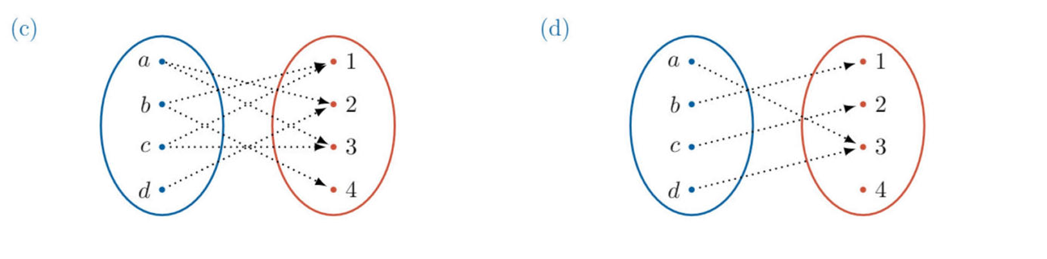

- $\{ \left(1,2\right), \left(4,5\right), \left(2,3\right) \}$ | - $\{ \left(2,5\right), \left(2,7\right), \left(3,5\right) \}$

Foundation
- Decide whether the following relations are functions.
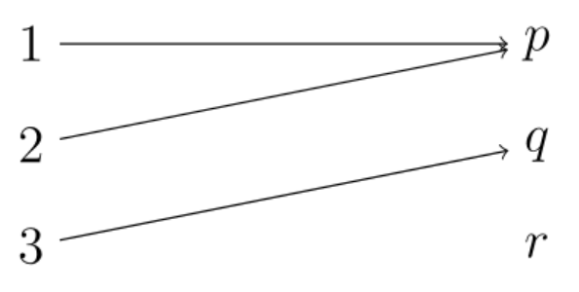  function | 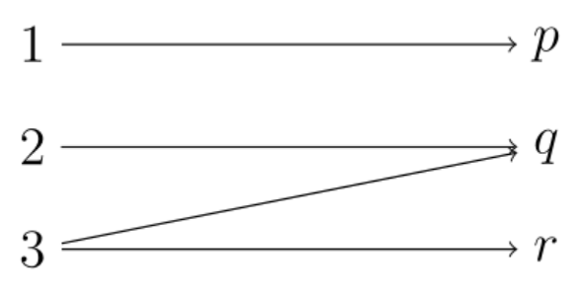  Not function
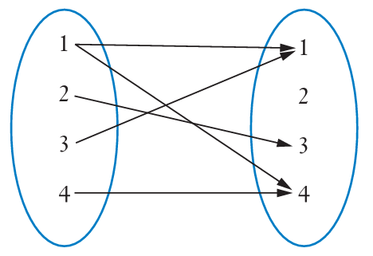  not function | 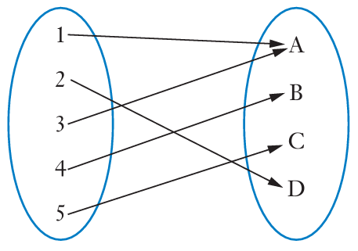  function
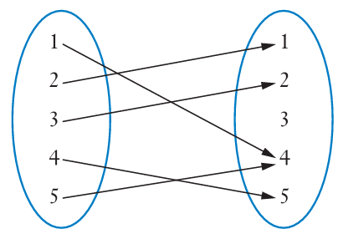  function | 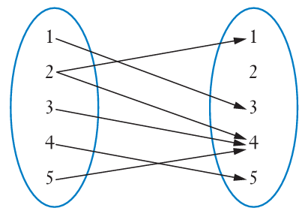  not function
- $(-4,1), (3,1), (5,2), (7,-2)$  function | - $(2,2), (3,3), (4,6), (4,9)$  not function
- $(1, 1), (2, 2), (3, 5), (3, 7)$  not function | - $(-3, 1), (3, 1), (8, 7), (9, -2), (11, 6)$  function
not function | Not function
  $$x$$ | $$3$$ | $$5$$ | 8 | $$9$$ | $$5$$
  $$y$$ | $$5$$ | $$2$$ | $$-7$$ | $$3$$ | $$6$$
  $$x$$ | $$1$$ | $$2$$ | 5 | $$8$$ | $$12$$
  $$y$$ | $$5$$ | $$7$$ | $$±8$$ | $$2$$ | $$1$$
- $(x, 5)$ for all real $x$  function | - $(2, y)$ for all real $y$  not function

Function Notation

- Function Machines and Function Notation
Another way to understand functions is to think of it as a ‘machine.’
A ‘function machine’ takes an input number, applies a rule, then gives out an output number.
$x$ is the input, $y$ is the output.
For a function, every input has at most one output.
An example is the linear function $y=2x+3$.
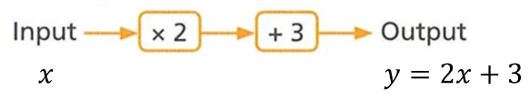

input
$$\underset{output}{\underbrace{f\left(x\right)}}=\underset{function rule}{\underbrace{2x+3}}$$

- Interpret Function notation
$$f\left(x\right)=2x+3 \\ f\left(7\right)=2\left(7\right)+3 \\ =17$$ | $$f\left(x\right)=2x+3 \\ f\left(10\right)=2\left(10\right)+3 \\ =23$$
- $f\left(x\right)=3x-5$  $$f\left(9\right)=$$ | - $f\left(x\right)=x^{2}+5x$  $$f\left(3\right)=$$
- $g\left(x\right)=x^{2}+3$  $$g\left(0\right)=$$ | - $f\left(x\right)={16}^{x}$  $$2f\left(-1\right)=$$
- $h\left(x\right)=\sin{x}$  $$h\left(30°\right)=$$ | - $P\left(x\right)=x^{2}-2x+5$  $$P\left(-3\right)-P\left(1\right)=$$

- Example Substitute an algebraic expression into a function
$f\left(x\right)=x^{2}+5x$, find $f\left(c\right).$  $$f\left(c\right)=c^{2}+5c$$ | $f\left(x\right)=x^{2}+5x$, find $f\left(x+1\right)$.  $f\left(x+1\right)={\left(x+1\right)}^{2}+5(x+1)$  $=x^{2}+2x+1+5x+5$  $=x^{2}+7x+6$

- Guided Practice
- $f\left(x\right)=x^{3}+3,$ find $f\left(n\right)$.  $$n^{3}+3$$ | - $g\left(x\right)=2x+3$, find $g(3-x)$.  $$9-2x$$
- $f\left(x\right)=-x^{2}$, find $f(x+1)$.  $$-x^{2}-2x-1$$ | - $f\left(x\right)=3x^{2}+2x$, find $f\left(x+h\right)$  $$3x^{2}+6xh+3h^{2}+2x+2h$$

- Example Solve $f\left(x\right)=c$
$f\left(x\right)=2x-5$, find $x$ when $f\left(x\right)=13$  $13=2x-5$  $18=2x$  $9=x$ | $f\left(x\right)=x^{2}-3x$, find $x$ when $f\left(x\right)=10$  $10=x^{2}-3x$  $0=x^{2}-3x-10$  $0=\left(x-5\right)\left(x+2\right)$  $x=5, -2$

- Guided Practice
- $f\left(x\right)=4x+11$, find $x$ when $f\left(x\right)=24$  $$x=\frac{13}{4}$$ | - $g\left(x\right)=x^{2}+3$, find $x$ when $g\left(x\right)=28$  $$x=±5$$

Foundation
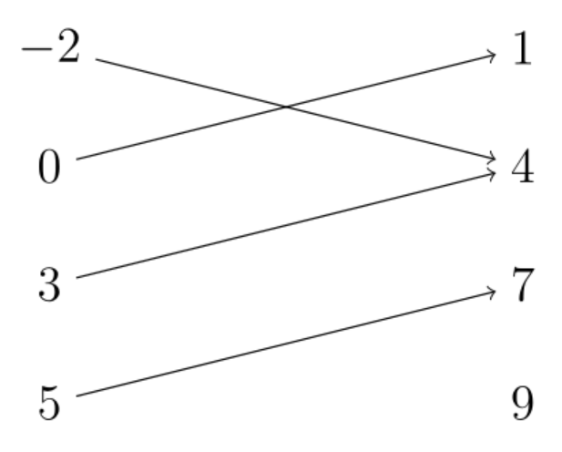
- The following shows inputs $x$ and the function outputs $f\left(x\right)$.
$$x$$ | $$-2$$ | $$0$$ | $$3$$ | $$5$$
$$f(x)$$ | $$4$$ | $$1$$ | $$4$$ | $$7$$

Write:
- $f\left(-2\right)$  4 | - $f\left(0\right)$  1 | - $f\left(5\right)$  7

- $f\left(x\right)=x^{2}-2x-3$. Find:
- $f\left(0\right)$  $$-3$$ | - $f\left(3\right)$  0 | - $f\left(-2\right)$  5

- $f\left(x\right)=x^{3}+8$. Find:
- $f\left(2\right)$  $$16$$ | - $f\left(0\right)$  8 | - $f\left(-2\right)$  0

- $f\left(x\right)=2^{x}$. Find:
- $f\left(2\right)$  $$4$$ | - $f\left(0\right)$  1 | - $f\left(-2\right)$  0.25

- $h\left(x\right)=3x-x^{2}.$ Find:
- $h\left(-3\right)$  $$-18$$ | - $h\left(1\right)$  2 | - $h\left(5\right)$  $$-10$$

- $h\left(x\right)=\sqrt{x+4}.$ Find:
- $h\left(-3\right)$  $$1$$ | - $h\left(1\right)$  $$\sqrt{5}$$ | - $h\left(5\right)$  3

  - $f(x)=3x+2$.
Find $a$ if $f(a)=14$.
$$a=4$$
  - $f(x)=3x+2$.
Find $a$ if $f(a)=-4$.
$$a=-2$$
  - $f(x)=x^{2}+1$.
Find all $a$ if $f(a)=10$.
$$a=±3$$
  - $f(x)=x^{2}+1$.
Find all $a$ if $f(a)=1$.
$$a=0$$
  - $f(x)=x^{2}+1$.
Find all real $a$ if $f(a)=0$.
No real solution
  - $f(x)=(x-2)^{2}$.
Find all $a$ if $f(a)=9$.
$$a=5 or -1$$
  - $f(x)=x^{2}+x+1$.
Find all $a$ if $f(a)=7$.
$$a=-3 or 2$$
  - $f(x)=2x^{2}-8$.
Find all $a$ if $f(a)=10$.
$$a=±3$$

- Find all real $a$ such that $f(a)=5.$
  - $f(x)=x+1$

$$a=4$$
  - $f(x)=2x+1$

$$a=2$$
  - $f(x)=x^{2}+1$

$$a=±2$$
  - $f(x)=x^{2}+5$

$$a=0$$
  - $f(x)=x^{2}+6$

No real solution

Development
- $f\left(x\right)=3x^{2}+1$. Find the following:
- $f\left(-3\right)$  $$28$$ | - $f\left(-a\right)$  $$3a^{2}+1$$ | - $f\left(a^{2}\right)$  $$3a^{4}+1$$
- $f\left(2a\right)$  $$12a^{2}+1$$ | - $f\left(\sqrt{a}\right)$  $$3a+1$$ | - $f\left(ab\right)$  $$3a^{2}b^{2}+1$$
- $f\left(2a-5\right)$  $$12a^{2}-60a+76$$ | - $f\left(1+a\right)$  $$3a^{2}+6a+4$$ | - $f\left(\frac{a}{b}\right)$  $$\frac{3a^{2}}{b^{2}}+1$$

- For the function $f\left(x\right)=3x+1$, find:
- $f\left(1\right)-2$  $$2$$ | - $3f\left(-1\right)$  $$-6$$ | - $f\left(9\right)÷f\left(2\right)$  $$4$$

- For the function $f\left(x\right)=x^{2}-3x+5$, find:
- $\frac{f\left(2\right)+f\left(3\right)}{2}$  $$4$$ | - $\frac{f\left(0\right)+4f\left(2\right)+f\left(4\right)}{6}$  $$4\frac{1}{3}$$

- For the function $f\left(x\right)=x^{2}-2x-4$, find:
- $f\left(1+\sqrt{5}\right)$  $$0$$ | - $f\left(\sqrt{3}-1\right)$  $$2-4\sqrt{3}$$
- Rewrite these functions with function notation $f\left(x\right)$.
- $y=8x$  $$f\left(x\right)=8x$$ | - $y=9-x^{2}$  $$f\left(x\right)=9-x^{2}$$ | - $y+7=x$  $$f\left(x\right)=x-7$$

- Make $y$ the subject then rewrite these functions with function notation.
- $2y+5=x$  $$f\left(x\right)=\frac{x-5}{2}$$ | - $3x+4y+5=0$  $$f\left(x\right)=-\frac{3x+5}{4}$$ | - $x=y^{3}$  $$f\left(x\right)=\sqrt[3]{x}$$

- Make $y$ the subject then rewrite these functions with function notation.
- $2x+y=7$; find $f(3)$. | - $2x+y=7$; find $f(-3)$. | - $2x+2y=8$; find $f(3)$.
- $3x+2y=8$; find $f(2)$. | - $3x-2y=8$; find $f(2)$. | - $5x-2y=1$; find $f(-1)$.

- For these real functions, explain why the function value cannot be found.
- $F(0)$, when $F\left(x\right)=\sqrt{x-4}$  $F\left(0\right)=\sqrt{-4}$, not real | - $g(3)$, when $g\left(x\right)=\sqrt{1-x^{2}}$  $g\left(3\right)=\sqrt{-8},$ not real
- $h(-2)$, when $h\left(x\right)=$ $\frac{1}{2+x}$  $$h\left(-2\right)=\frac{1}{0}, undefined$$ | - $f\left(0\right),$ when $f\left(x\right)=$ $\frac{1}{3x}$  $$f\left(0\right)=\frac{1}{0}, undefined$$

- Find $g\left(a+1\right)$ for:
- $g\left(x\right)=2-x$  $$1-a$$ | - $g\left(x\right)=x^{2}$  $$a^{2}+2a+1$$ | - $g\left(x\right)=$ $\frac{1}{x-1}$  $$\frac{1}{a}$$

- Find $f\left(t\right)-2$ and $f\left(t-2\right)$ for:
- $f\left(x\right)=5x+2$  $$5t | 5t-8$$ | - $f\left(x\right)=\sqrt{x}$  $$\sqrt{t}-2 | \sqrt{t-2}$$ | - $f\left(x\right)=2-x^{2}$  $$-t^{2} | -t^{2}+4t-2$$

- Let $g\left(x\right)=4x+1$
Find and simplify each pair.
- $g\left(2a\right)$ and $2g\left(a\right)$  $$8a+1 | 8a+2$$ | - $g\left(3a\right)$ and $3g\left(a\right)$  $$12a+1 | 12a+3$$ | - $g\left(a^{2}\right)$ and ${\left(g\left(a\right)\right)}^{2}$  $$4a^{2}+1 | 16a^{2}+8a+1$$
- $g\left(a+1\right)$ and $g\left(a\right)+1$  $$4a+5 | 4a+2$$ | - $g\left(-a\right)$ and $-g\left(a\right)$  $$1-4a | -4a-1$$

Mastery
- $f\left(x\right)=x^{2}+5x$. Find, in simplest form:
$$\frac{f\left(1+h\right)-f\left(1\right)}{h}$$  $$7+h$$ | $$\frac{f\left(p\right)-f(q)}{p-q}$$  $$p+q+5$$ | $$\frac{f\left(x+h\right)-f(x)}{h}$$  $$2x+h+5$$

- For each claim, simplify both sides. State true for all valid $x$ or not an identity.
- If $f(x)=x^{2}-x$,  then $f(1-x)=f(x)$.  True for all 𝑥 | - If $f(x)=x^{2}$,  then $f(-x)=f(x)$.  True for all 𝑥
- If $f(x)=x^{2}+1$,  then $f(-x)=f(x)$.  True for all 𝑥 | - If $f(x)=x^{2}+x$,  then $f(-x)=f(x)$.  Not an identity (only true when 𝑥=0)
- If $f(x)=3x-2$,  then $f(x+1)=f(x)+3$.  True for all 𝑥 | - If $f(x)=3x-2$,  then $f(2x)=2f(x)$.  Not an identity
- If $f(x)=\frac{1}{x}$,  then $f​\left(\frac{1}{x}\right)=x$ for $x≠0$.  True for all 𝑥≠0 | - If $f(x)=x+\frac{1}{x}$,  then $f​\left(\frac{1}{x}\right)=f(x)$ for $x≠0$.  True for all 𝑥≠0

- By finding expressions for the LHS and RHS, show that these are true for $f\left(x\right)=x^{2}$.
- $f\left(4x\right)=16f\left(x\right)$ | - $f\left(xy\right)=f\left(x\right)f\left(y\right)$
- $f\left(\frac{x}{y}\right)$ $=$ $\frac{f\left(x\right)}{f\left(y\right)}$ | - $f\left(x^{2}\right)={\left(f\left(x\right)\right)}^{2}$
- $f\left(x+y\right)+f\left(x-y\right)=2\left(f\left(x\right)+f\left(y\right)\right)$

- Find $f\left(k\right)-f\left(k-1\right)$ in simplest form for:
- $f\left(x\right)=3x^{2}+2x$  $$6k-1$$ | - $f\left(x\right)=$ $\frac{1}{x}$  $$\frac{1}{k\left(1-k\right)}$$ | - $f\left(x\right)=2^{x}$  $$2^{k-1}$$

- By finding expressions for the LHS and RHS, show that these are true for $f\left(x\right)=4^{x}$.
- $4f\left(x\right)=f\left(x+1\right)$  True | - $f\left(x+1\right)-f\left(x\right)=3f\left(x\right)$  True

- $f\left(x\right)=2^{x}$  Show that $f\left(x\right)×f\left(-x\right)=1$. | - $f\left(x\right)=x-x^{3}$  Show that $f\left(-x\right)=-f\left(x\right)$.
- $f\left(x\right)=$ $\frac{x}{x+1}$  Show that $f\left(x\right)+f\left(\frac{1}{x}\right)=1$. | - $f\left(x\right)=$ $\frac{x}{x^{2}+1}$  Show that $f\left(\frac{1}{x}\right)=f\left(x\right)$.
- $f\left(x\right)=px^{2}-x$.  Find $p$ if $f\left(-3\right)=2f\left(2\right)$.  $$p=-7$$ | - $f\left(x\right)=$ $\frac{x}{x^{2}-1}$  Show that $f\left(x\right)+f\left(\frac{1}{x}\right)=0$.
- $f\left(x\right)=$ $\frac{a-x}{1+bx}$.  Show that $f\left(\frac{a-x}{1+bx}\right)=x$ | - $c\left(x\right)=$ $\frac{3^{x}+3^{-x}}{2}$ $, s\left(x\right)=$ $\frac{3^{x}-3^{-x}}{2}$  Show that ${\left(c\left(x\right)\right)}^{2}-{\left(s\left(x\right)\right)}^{2}=1$

Vertical Line Test

- The Vertical Line Test
We can plot relations as coordinates $\left(x,y\right)$ on a Cartesian plane and make a graph.
For a function, every input has at most one output.
This means any vertical line will intersect the graph of a function at most once.
If a vertical line intersects a graph more than once, then the graph is not a function.
Function  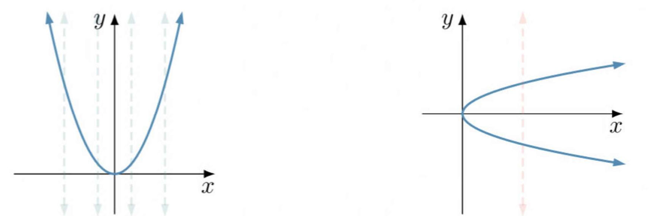 | Not a Function
A closed circle ● means the point is on the graph.
An open circle ○ means it is not.

- Decide whether a graph represents a function using the vertical line test
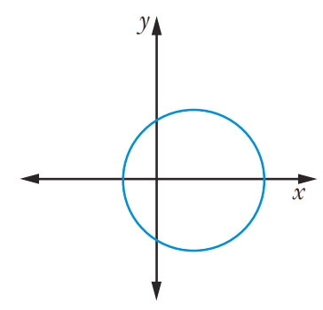  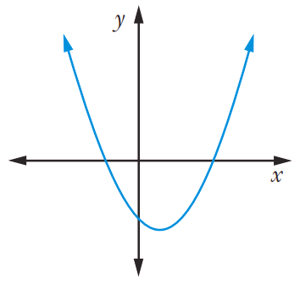 |  | 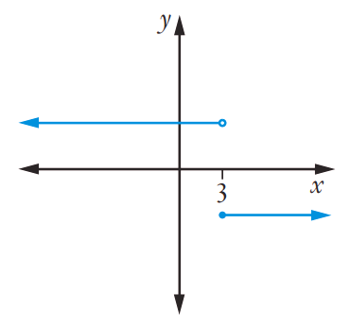
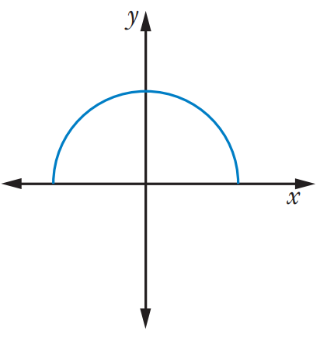
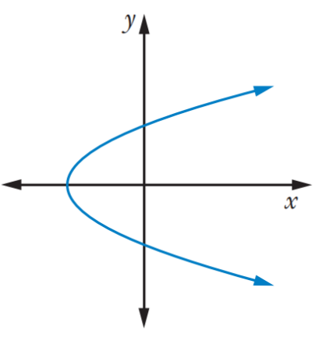
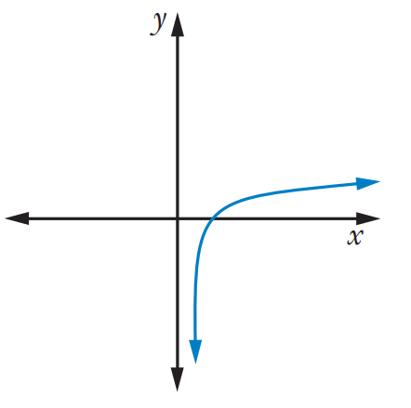

Foundation
- Decide whether these relations show a function using the vertical line test.
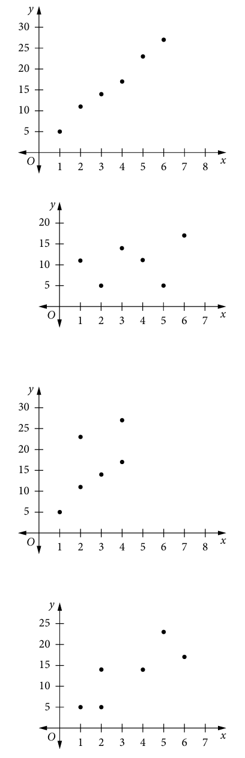  function | function | not function
not function | 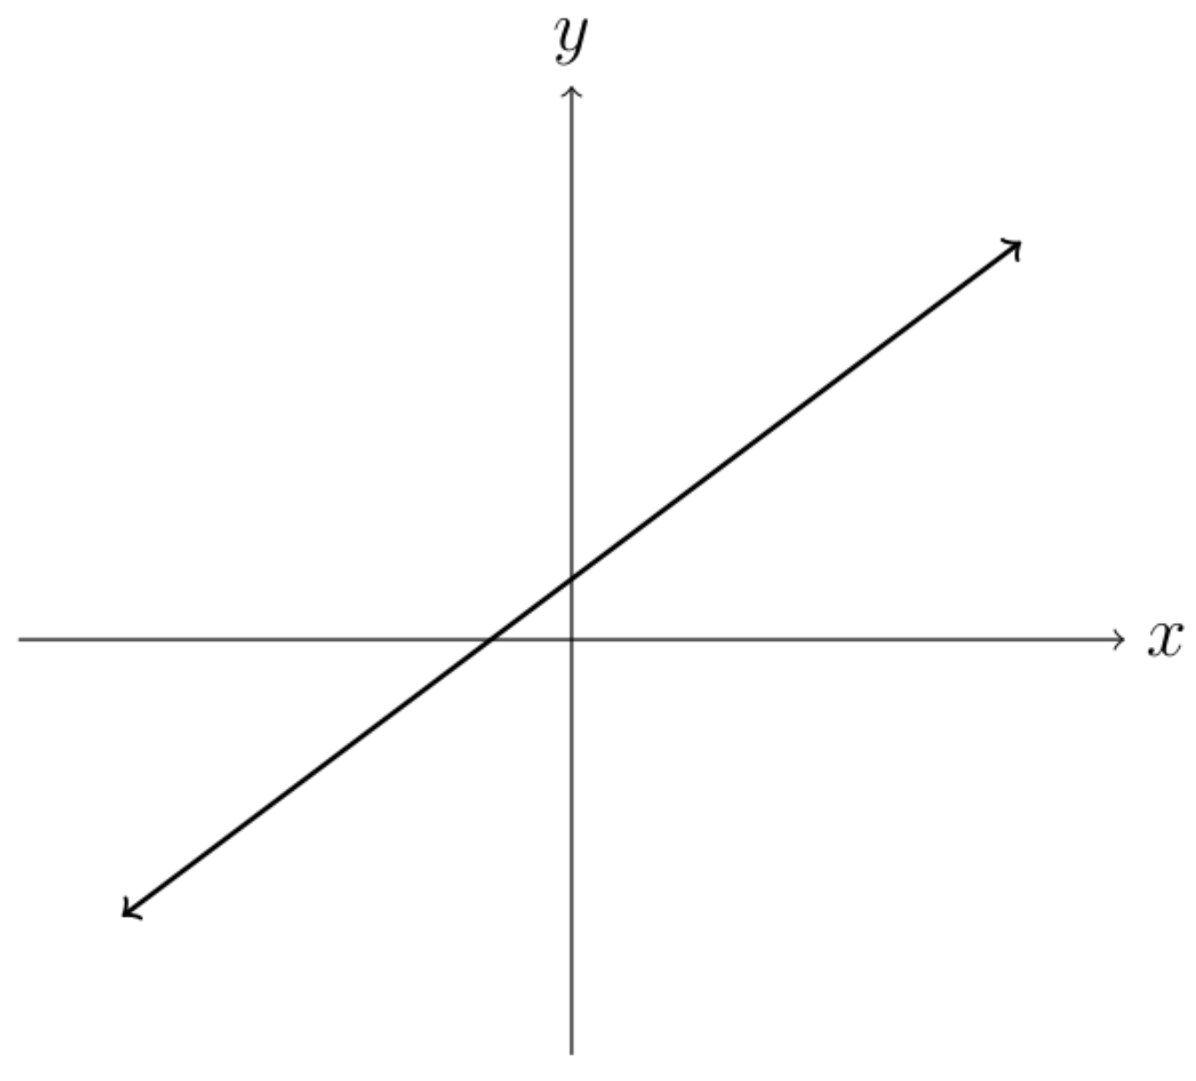  function | 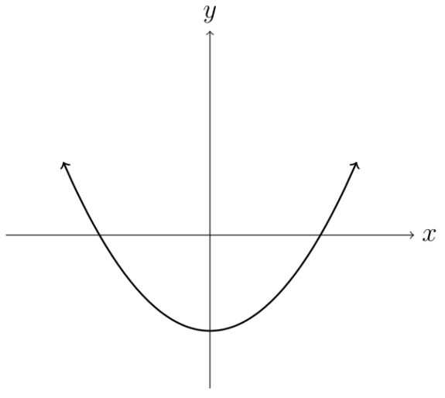  function
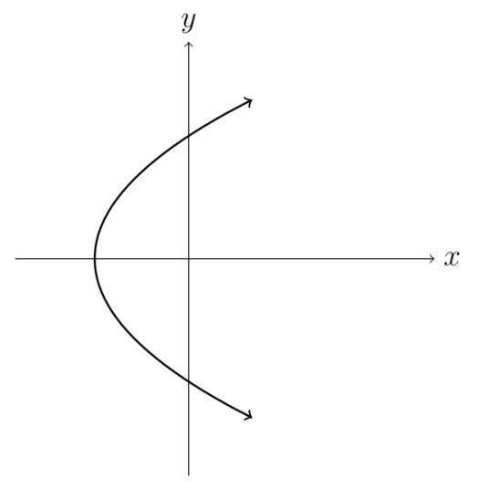  not function | 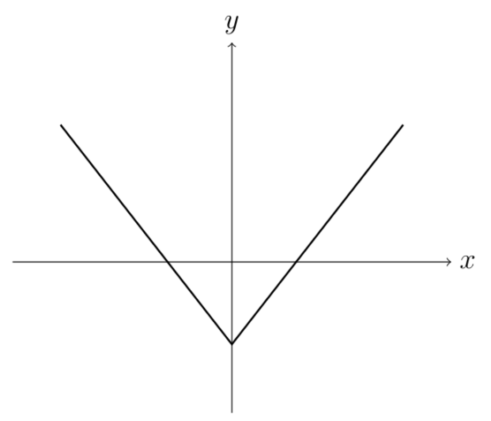  function | 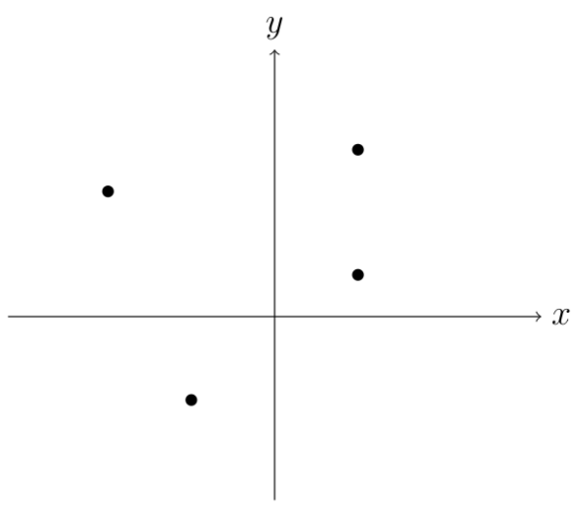  not function
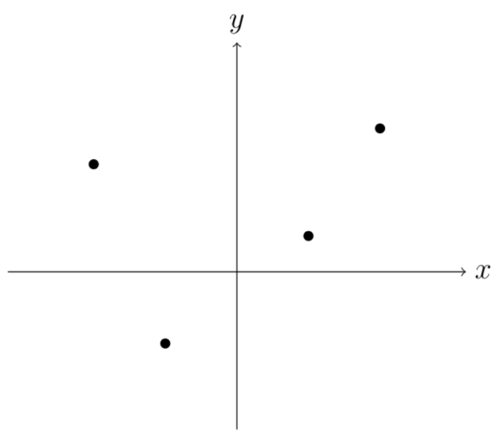  function | function | 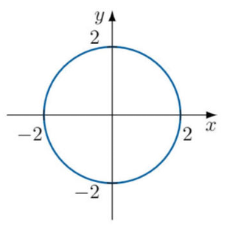  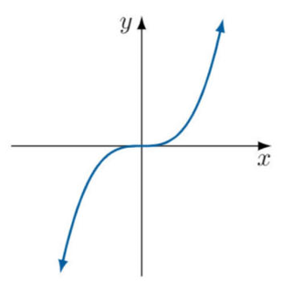  not function
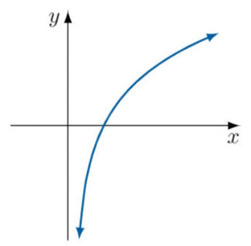  function | 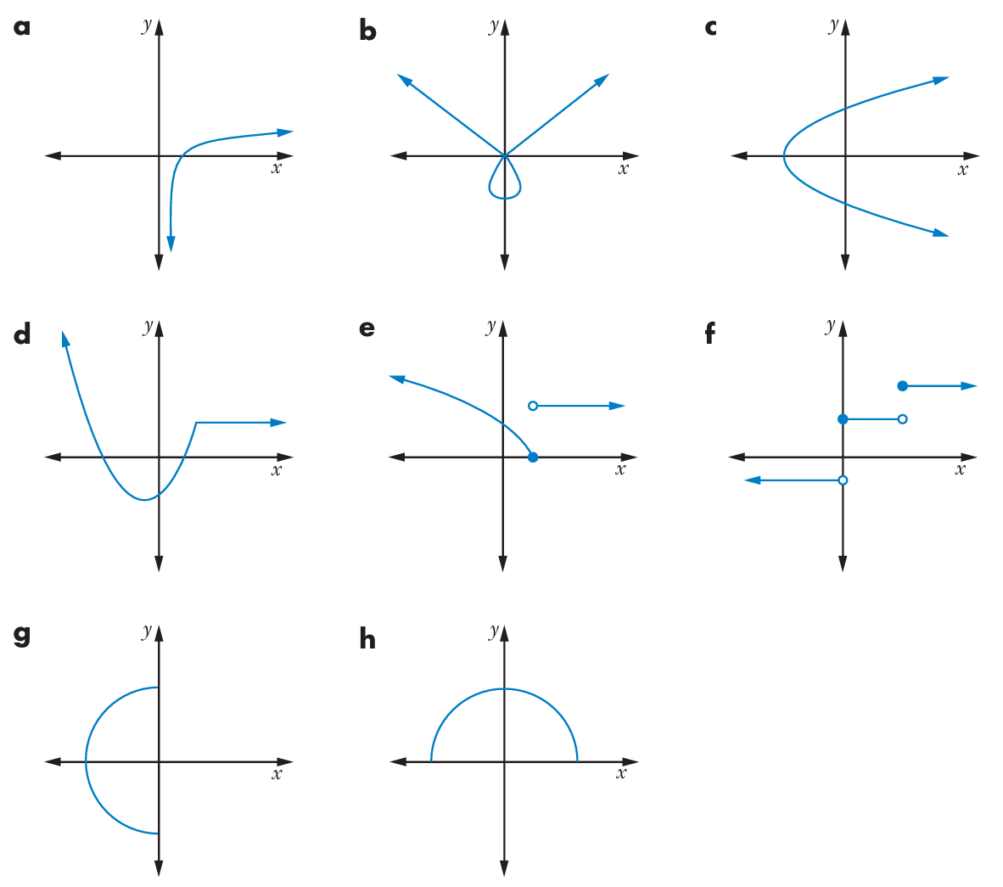  not function | function
not function | function | function
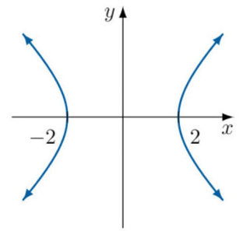  not function | 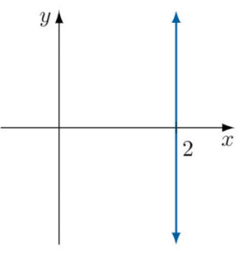  not function | 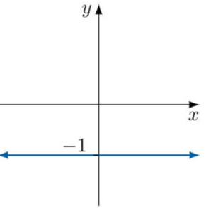  function

Function Notation and Graphs

- $f\left(a\right)$ and $f\left(x\right)=c$
For a function $y=f\left(x\right)$
$f\left(a\right)$means find the $y$ coordinate when $x=a$.
$f\left(x\right)=c$ means find the $x$ coordinate when $y=c$.

- Interpret Function notation and the graph
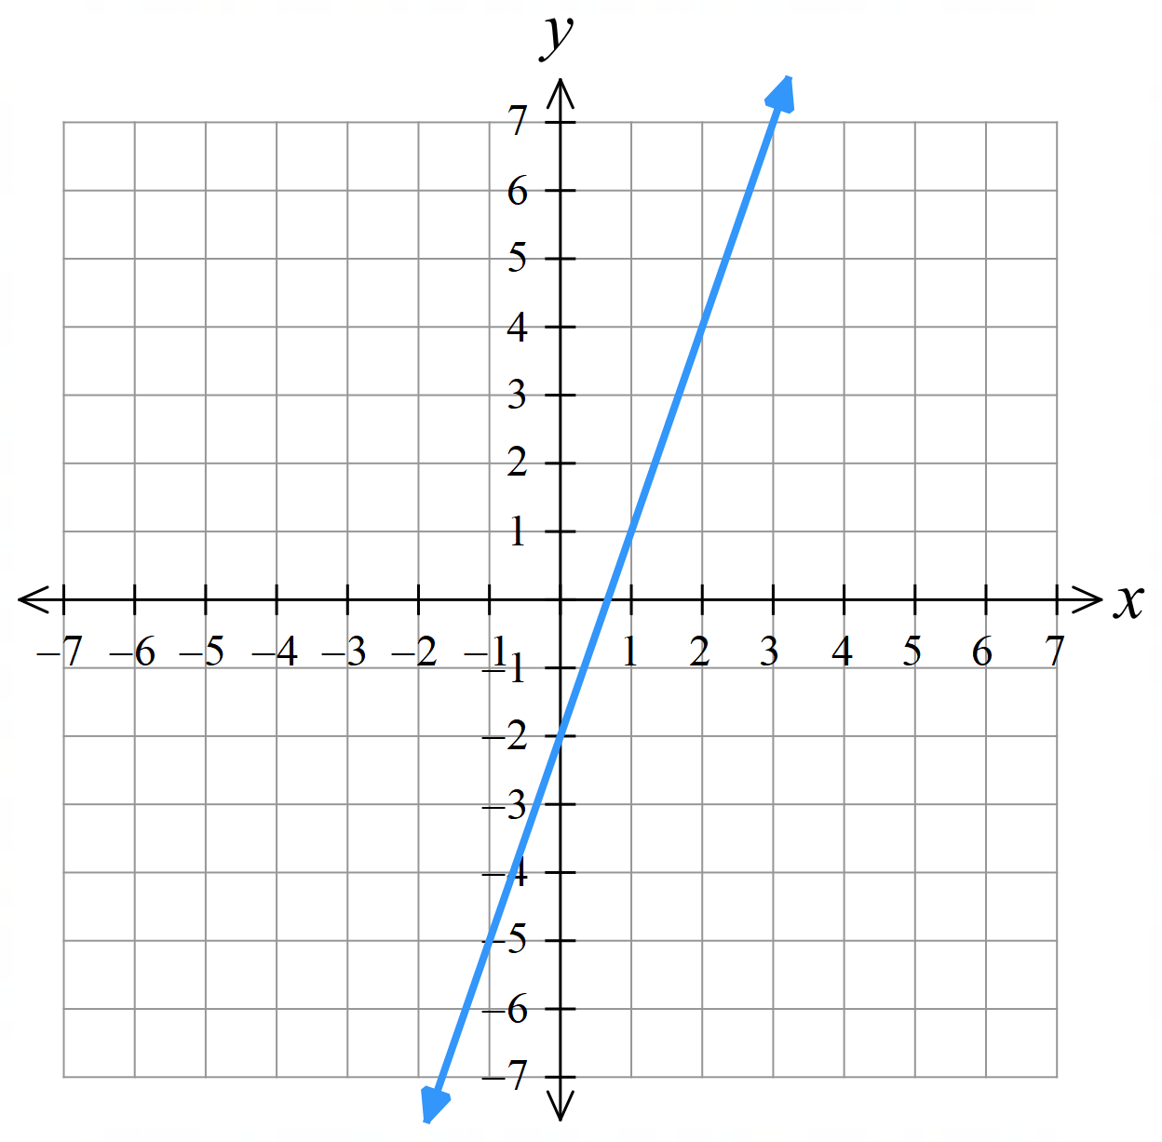  Evaluate $f\left(0\right)$  Evaluate $f\left(1\right)$  Evaluate $f\left(-1\right)$  Evaluate $f\left(3\right)$  Find $x$ when $f\left(x\right)=4$  Find $x$ when $f\left(x\right)=-2$ | 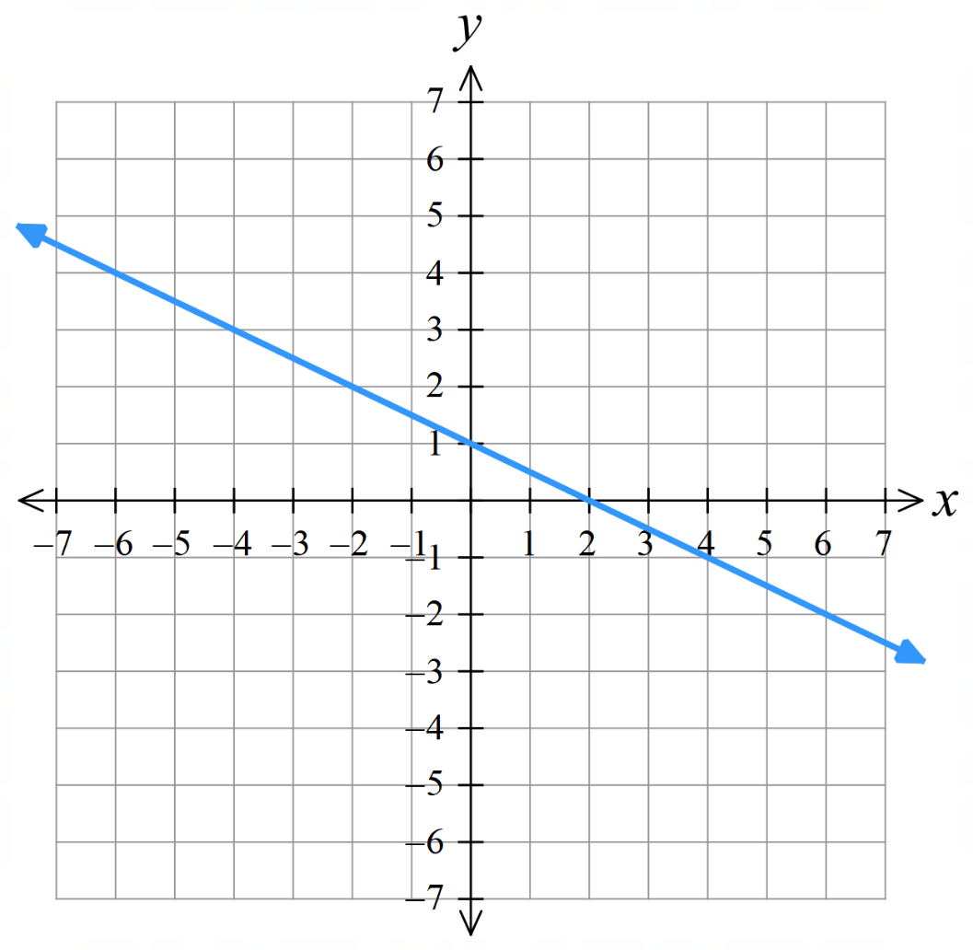  Evaluate $f\left(0\right)$  Evaluate $f\left(1\right)$  Evaluate $f\left(2\right)$  Evaluate $f\left(-3\right)$  Find $x$ when $f\left(x\right)=4$  Find $x$ when $f\left(x\right)=-2$

Foundation

Evaluate $f\left(0\right)$  $$f\left(0\right)=-3$$  Evaluate $f\left(4\right)$  $$f\left(4\right)=-1$$  Evaluate $f\left(-5\right)$  $$f\left(-5\right)=-5.5$$  Find $x$ when $f\left(x\right)=-5$  $$x=-4$$  Find $x$ when $f\left(x\right)=-1.5$  $$x=3$$  Find $x$ when $f\left(x\right)=0$  $$x=6$$ | 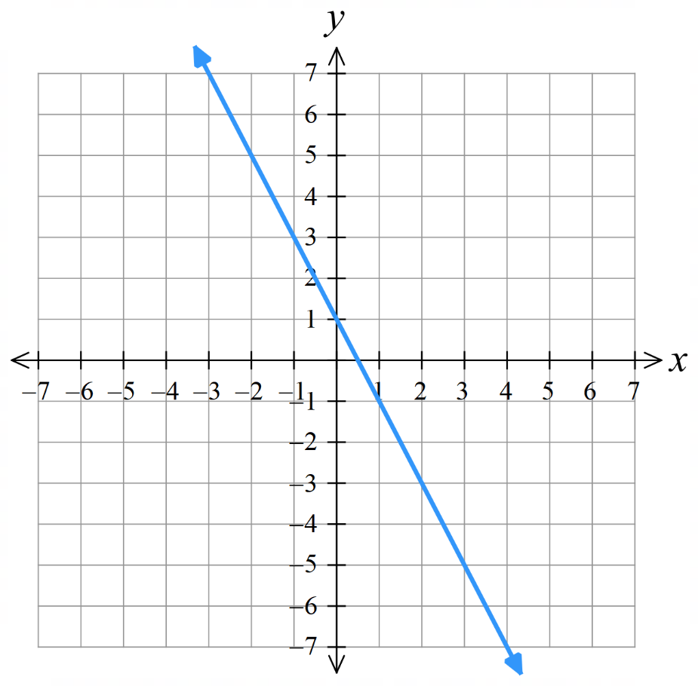  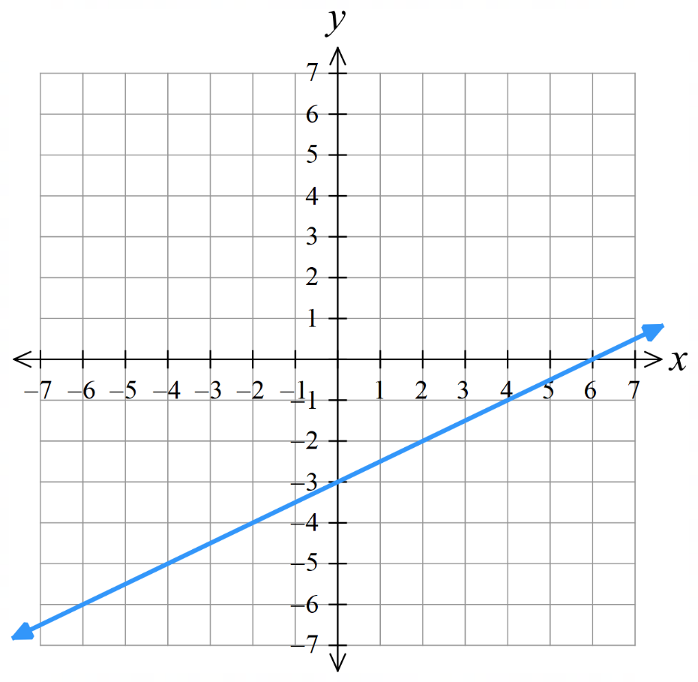  Evaluate $f\left(-1\right)$  $$f\left(-1\right)=3$$  Evaluate $f\left(2.5\right)$  $$f\left(2.5\right)=-4$$  Find $x$ when $f\left(x\right)=2$  $$x=-0.5$$  Find $x$ when $f\left(x\right)=-7$  $$x=4$$  Evaluate $f\left(-\frac{3}{2}\right)$  $$f\left(-\frac{3}{2}\right)=4$$
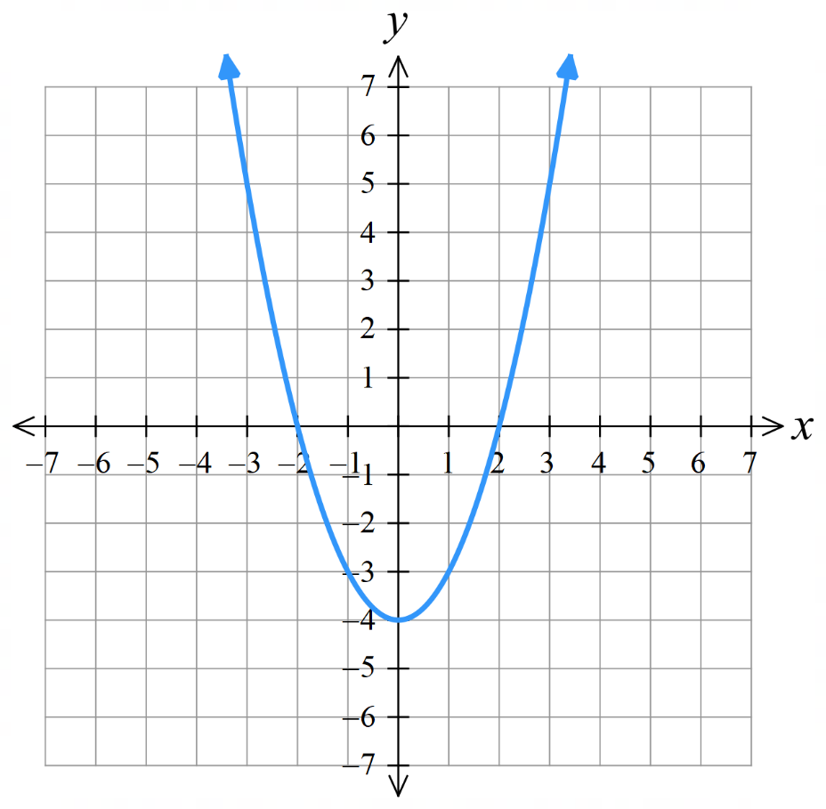  Evaluate $f\left(0\right)$  $$f\left(0\right)=-4$$  Find $x$ when $f\left(x\right)=0$  $x=-2$ or $2$  Evaluate $f\left(1\right)$  $$f\left(1\right)=-3$$  Find $x$ when $f\left(x\right)=5$  $x=-3$ or 3 | 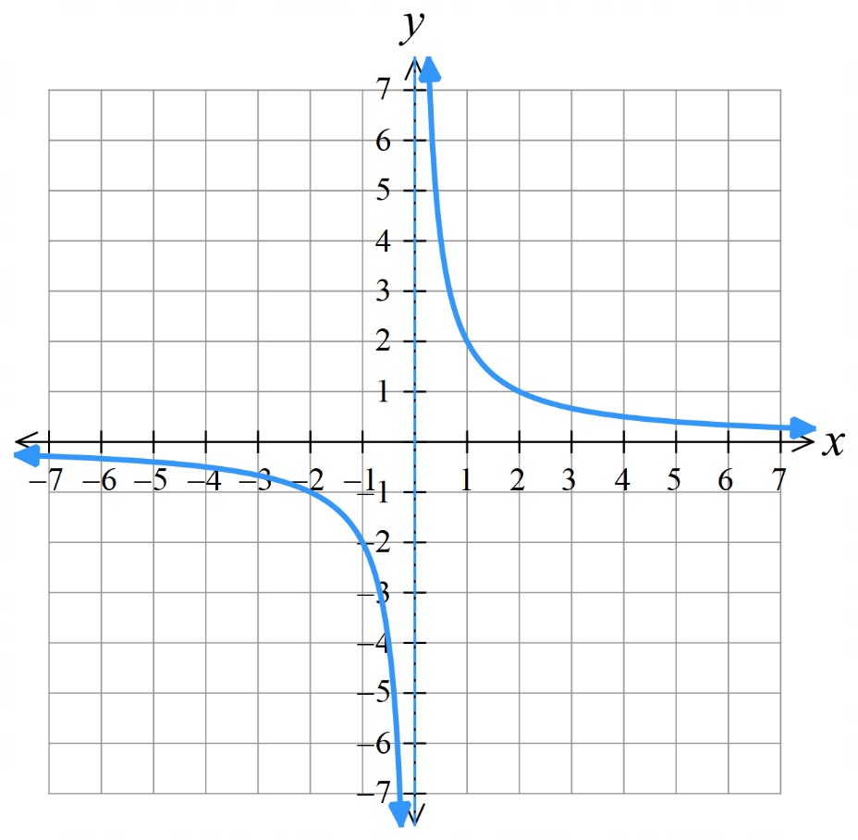  Evaluate $f\left(1\right)$  $$f\left(1\right)=2$$  Evaluate $f\left(-2\right)$  $$f\left(-2\right)=-1$$  Evaluate $f\left(0\right)$  $f\left(0\right)$ is undefined  Find $x$ when $f\left(x\right)=-2$  $$x=-1$$

Development
- The $y$-intercept of a function is at $x=0$. Write the $y$-intercept using function notation.

$$f\left(0\right)$$
- The $x$-intercept(s) of a function is at $y=0$. Write the $x$-intercept(s) using function notation.
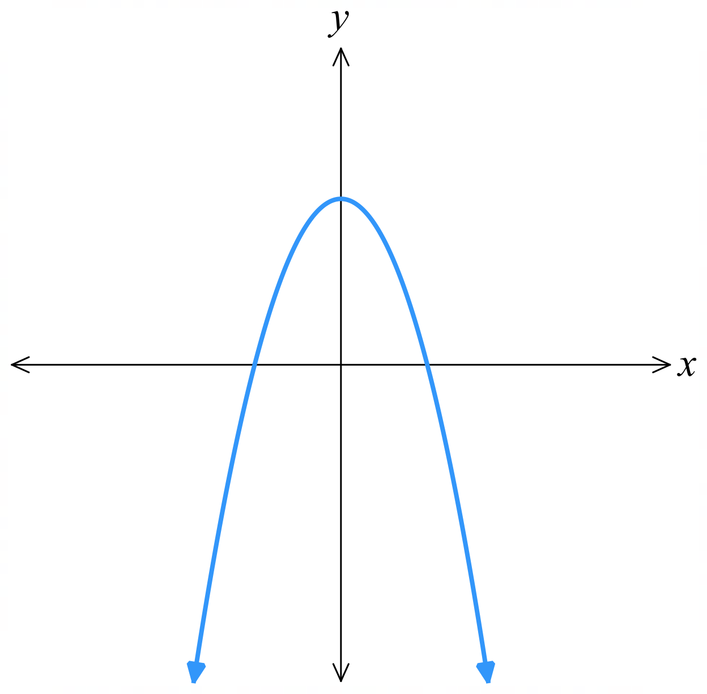
$$f\left(x\right)=0$$
- The graph of $f\left(x\right)=4-x^{2}$ is shown.
  - Find $f\left(0\right)$ and show the point on the graph.
(0,4)
  - Find $f\left(x\right)=0$ and show the points on the graph.

(–2,0) and (2,0)
  - Find $f\left(4\right)$ and show the point on the graph.
(4,–12)

- Consider the following tables of values showing $x$ and $f\left(x\right)$.
Evaluate $f\left(0\right)$  $$f\left(0\right)=5$$  Evaluate $f\left(2\right)$  $$f\left(2\right)=9$$  Find $x$ when $f\left(x\right)=1$  $$x=-2$$  Find $x$ when $f\left(x\right)=3$  $$x=-1$$  Find $x$ when $f\left(x\right)=9$  $$x=2$$ | Evaluate $f\left(-2\right)$  $$f\left(-2\right)=1$$  Evaluate $f\left(1\right)$  $$f\left(1\right)=-2$$  Find $x$ when $f\left(x\right)=-2$  $$x=1$$  Find $x$ when $f\left(x\right)=1$  $x=-2$ or $2$  Evaluate $f\left(-3\right)$  $$f\left(-3\right)=6$$
  $$x$$ | $$-2$$ | $$-1$$ | 0 | $$1$$ | $$2$$
  $$f\left(x\right)$$ | $$1$$ | $$3$$ | $$5$$ | $$7$$ | $$9$$
  $$x$$ | $$0$$ | $$-3$$ | $$-2$$ | $$2$$ | $$1$$
  $$f\left(x\right)$$ | $$-3$$ | $$6$$ | $$1$$ | $$1$$ | $$-2$$

- Consider these representations of functions.
- $(-4,1), (3,1), (5,2), (7,-2)$  Evaluate $f\left(3\right)$  $$f\left(3\right)=1$$  Evaluate $f\left(7\right)$  $$f\left(7\right)=-2$$  Find $x$ when $f\left(x\right)=2$  $$x=5$$  Find $x$ when $f\left(x\right)=1$  $x=-4$ or 3 | 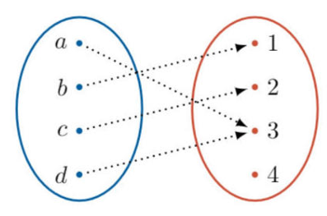  - $x$ $f\left(x\right)$  Evaluate $f\left(a\right)$  $$f\left(a\right)=3$$  Find $x$ when $f\left(x\right)=1$  $$x=b$$  Find $x$ when $f\left(x\right)=4$  No solution  Find $x$ when $f\left(x\right)=3$  $x=a$ or $d$

Zeroes and $f$(0)

- Zeroes of a function and $f\left(0\right)$
For $y=f\left(x\right)$:
$f\left(0\right)$ is the $y$-intercept.
A zero of the function is the $x$ value where $f\left(x\right)=0$. (i.e., the $x$-intercept).
A function can have many zeroes but only one $f\left(0\right)$.
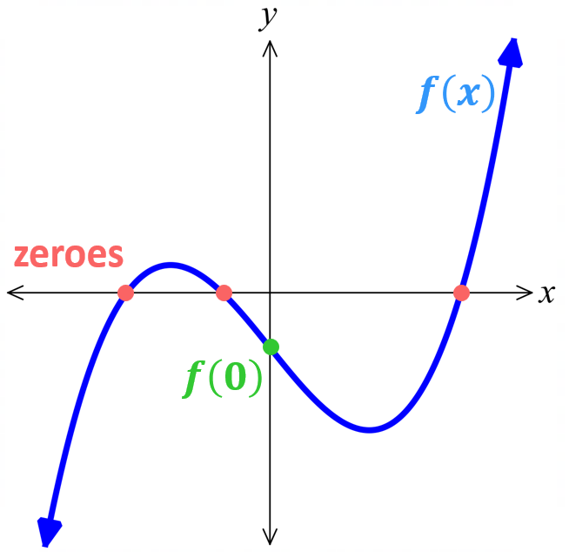

- Identify Zeroes of a function and $f\left(0\right)$
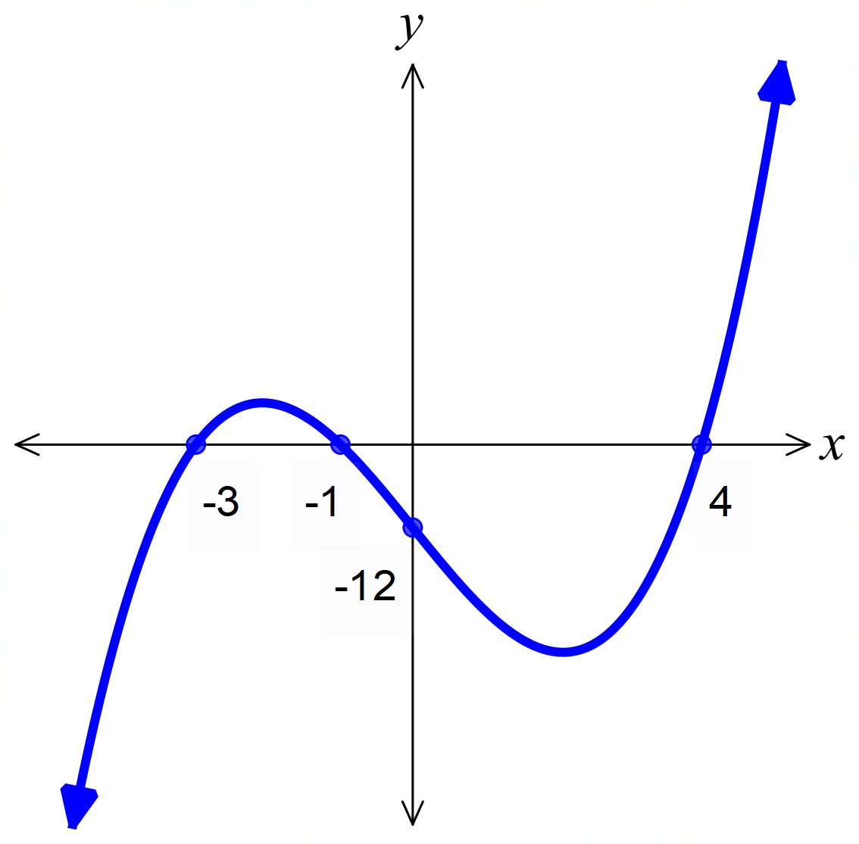  Zeroes:  $f\left(0\right)=$ | 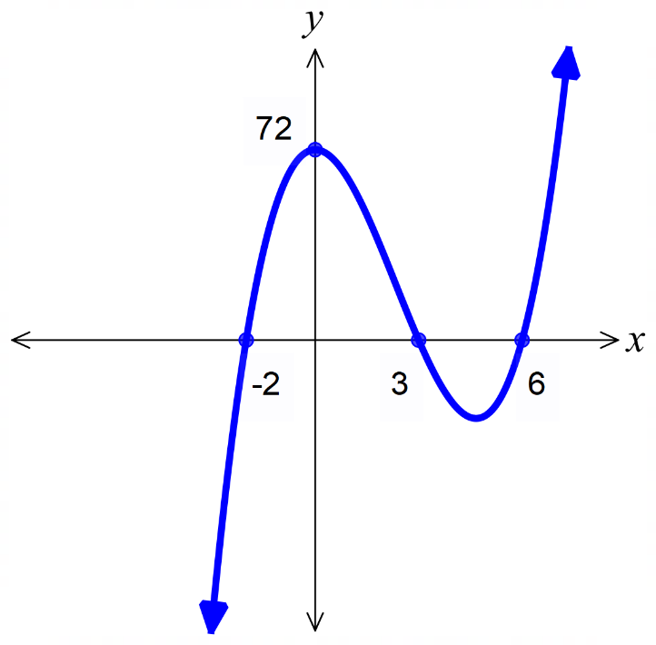  Zeroes:  $f\left(0\right)=$
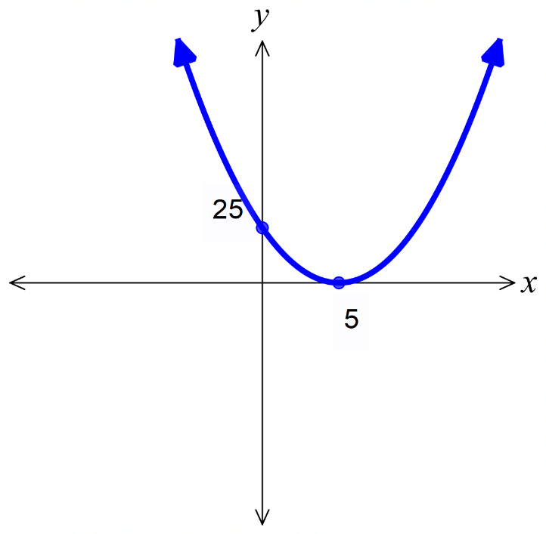  Zeroes:  $f\left(0\right)=$ | 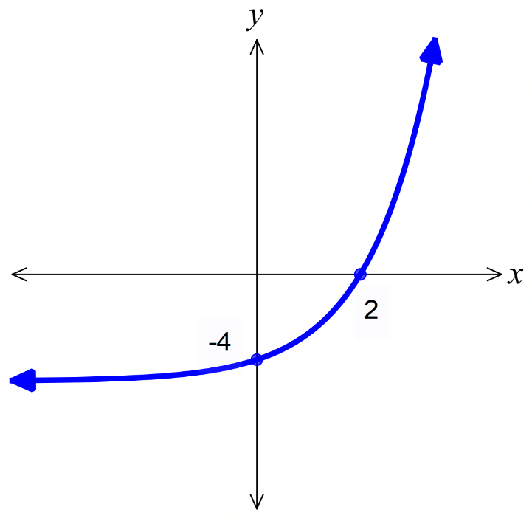  Zeroes:  $f\left(0\right)=$

- Key Ideas
- When you are asked to find $f\left(0\right)$, that means find the …… value when …… = 0. In other words, find the ……-intercept.
- When you are asked to find the zero(es) of a function, that means find where …… = 0, in other words, find the ……-intercept(s).

Interval Notation

- Investigation Interval notation
There are two ways of writing the same interval:
$$-1≤x<3$$
$$[-1, 3)$$
- What is true about the $[$ and $)$ symbols?
- $[$ and ] are used to include a value, just like $≤$ and $≥$
- $($ and $)$ are used to exclude a value, just like $<$ and $>$
- Both above statements are true.

- What does $\left[2,4\right]$ mean?  - $2≤x≤4$  - $2<x<4$  - $2≤x<4$ | - What does $[2,4)$ mean?  - $2≤x≤4$  - $2<x<4$  - $2≤x<4$
- How would you represent $x≥0$ in interval notation?
- $[0,∞)$ since $∞$ can’t be an included value.
- $[0,∞]$ since $∞$ can be an included value.
- Write these inequalities using interval notation.
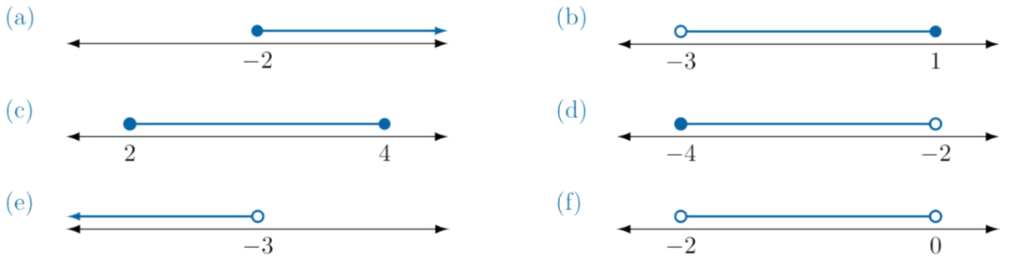

When you have two separate inequalities, we use the union symbol $∪$
$$x≤1, x≥3$$
$$\left(-∞, 1\right]∪\left[3,∞\right)$$
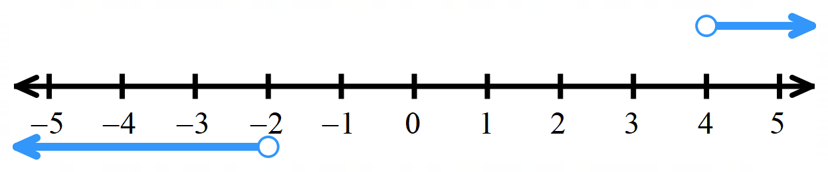 | 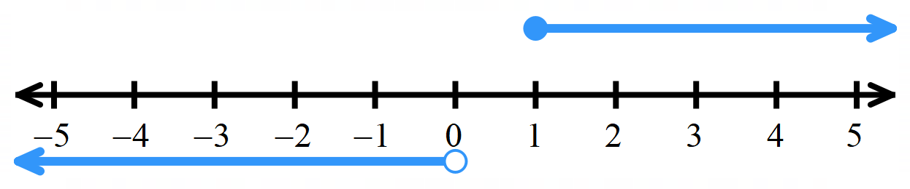

Foundation
- Complete the table.
 | Inequality | Interval Notation | Graph
 | $$-3≤x<5$$ | $$\left[-3, 5\right)$$ | 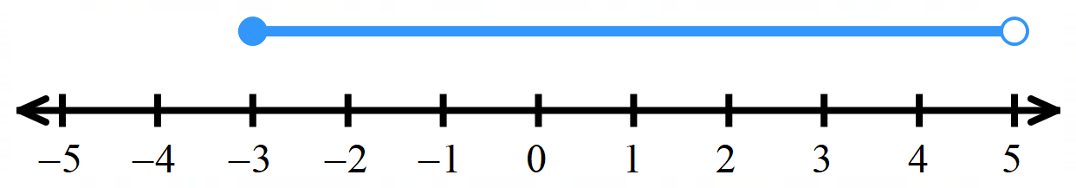
 | $$-1≤x≤3$$ | $$\left[-1,3\right]$$ | 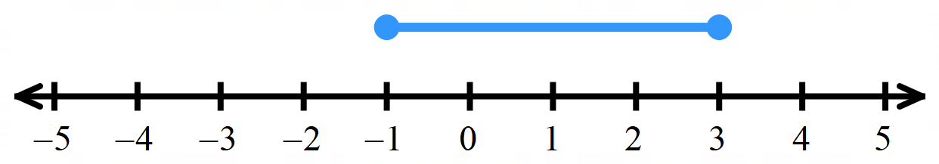
 | $$x>2$$ | $$\left(2,∞\right)$$ | 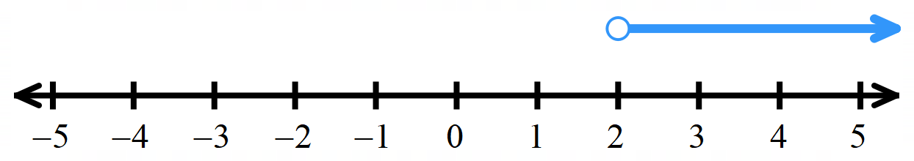
 | $$x≤3$$ | $$(-∞,3]$$ | 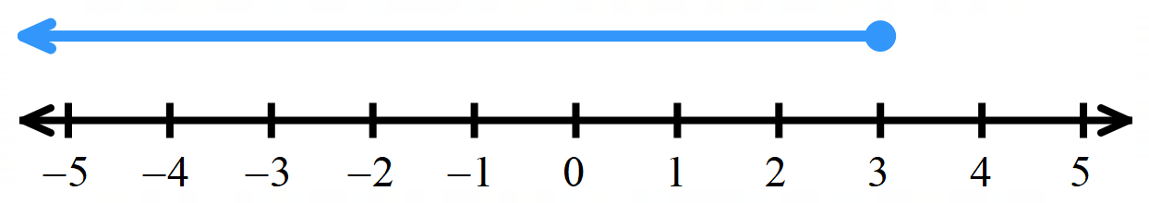
 | $$x<4$$ | $$\left(-∞,4\right)$$ | 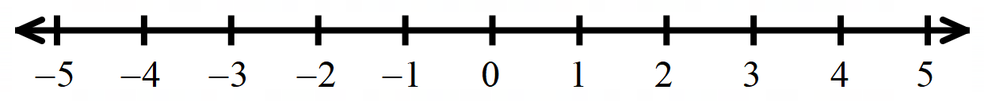
 | $$x≥5$$ | $$\left[5,∞\right)$$
 | $$x<-2$$ | $$\left(-∞, -2\right)$$ | 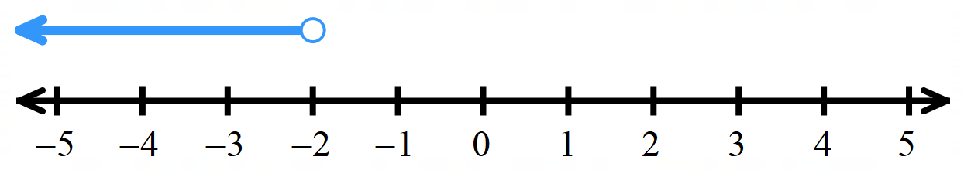
 | $x<1$ or $x≥3$ | $$(-∞, 1)∪[3,∞)$$ | 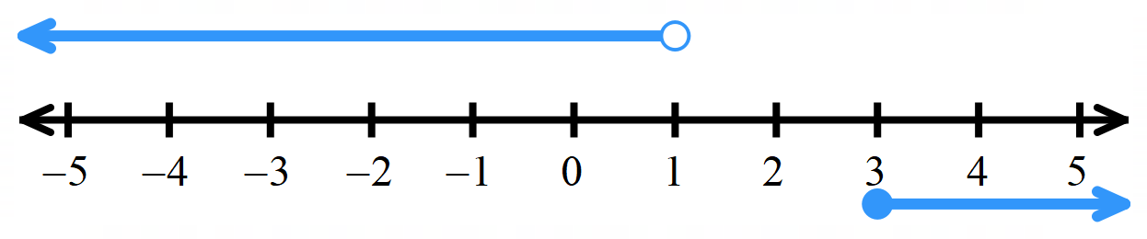
 | $x≤-1$ or $x≥2$ | $$\left(-∞,-1\right]∪[2,∞)$$ | 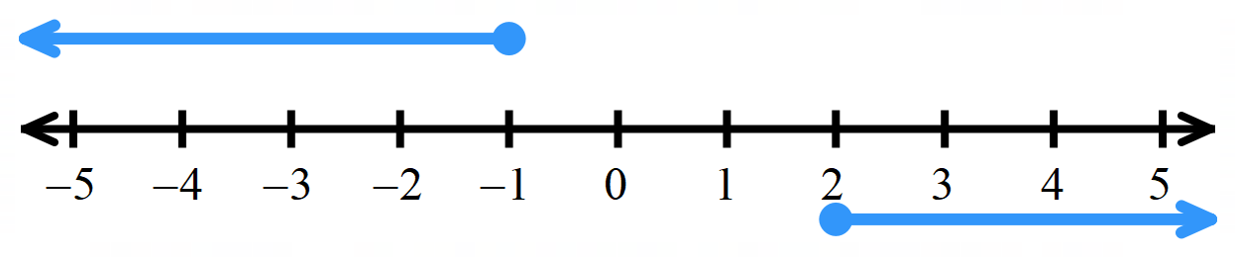
 | $$-4<x≤-1$$  or$x≥3$ | $$\left(-4,-1\right]∪\left[3,∞\right]$$ | 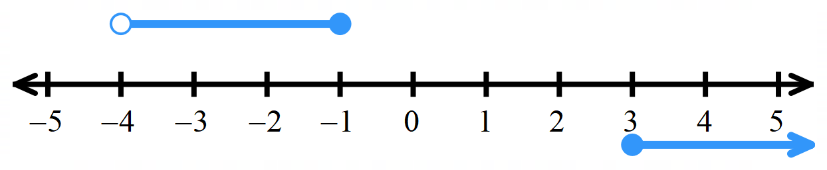
 | $x<-3$ or  $$0≤x≤2$$ | $$\left(-∞,-3\right)∪[0,2]$$ | 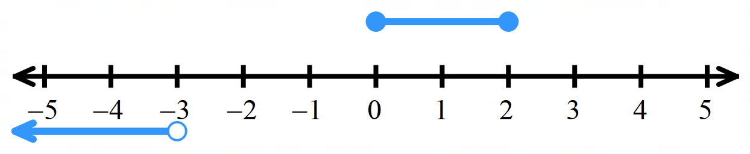

Domain and Range

- Investigation Domain
The domain is the allowable inputs of a function, or the $x$ values for which a function exists.
We can specify a domain with an interval, and we can visualise it as a shadow on the $x$-axis.
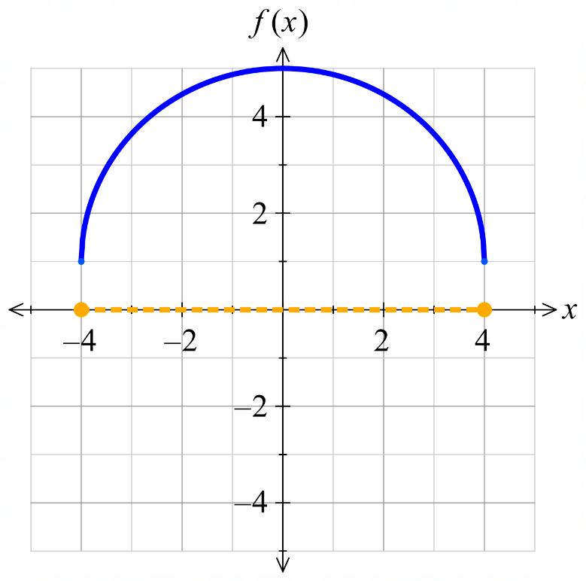  The domain is $-4≤x≤4$ | 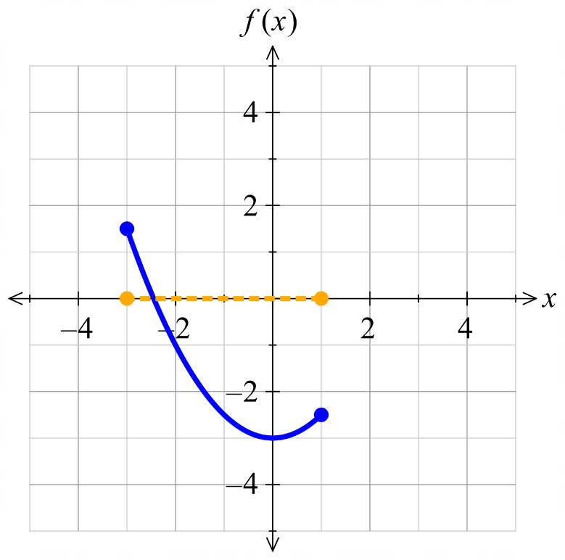  The domain is …… $≤x≤$ ……
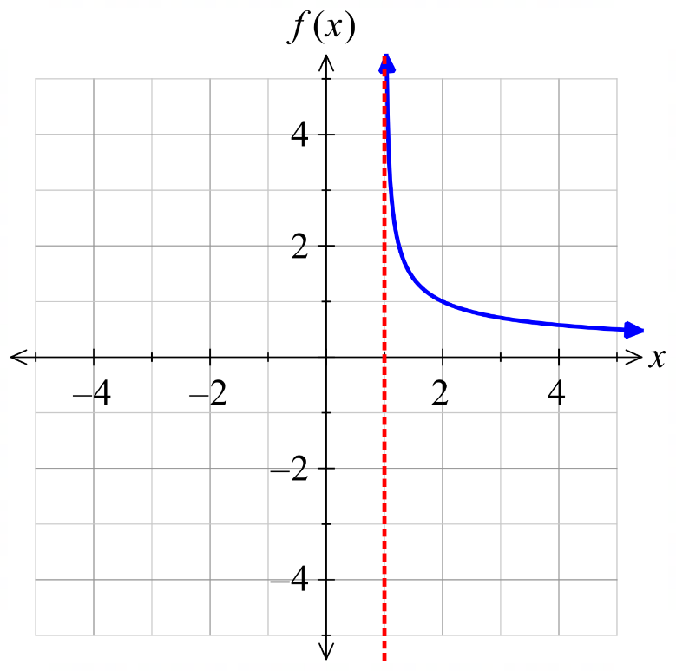  The domain is: (choose one)  - $x≥1$  - $x>1$  - $x$ can be any real number | Match the domain to the function.  $x>-2$ $x≥-2$ $x≤1$ $x>0$
  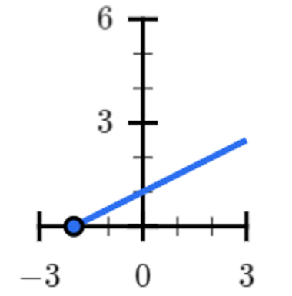
  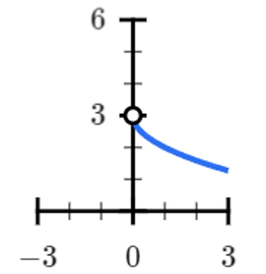
  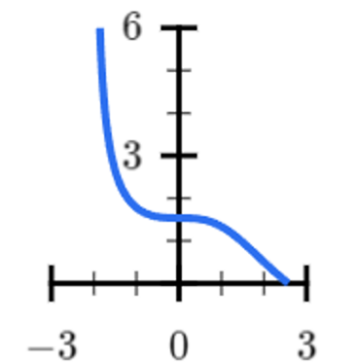 | 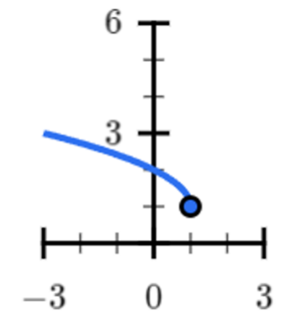

- Investigation Domain
What is the domain, using interval notation?
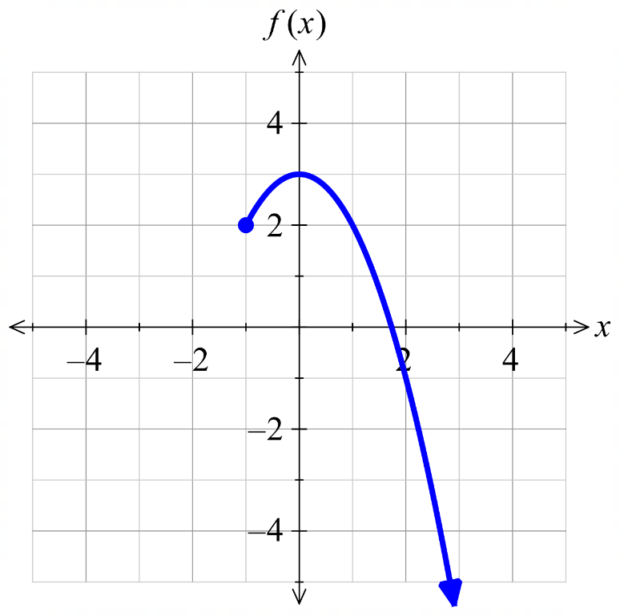 | 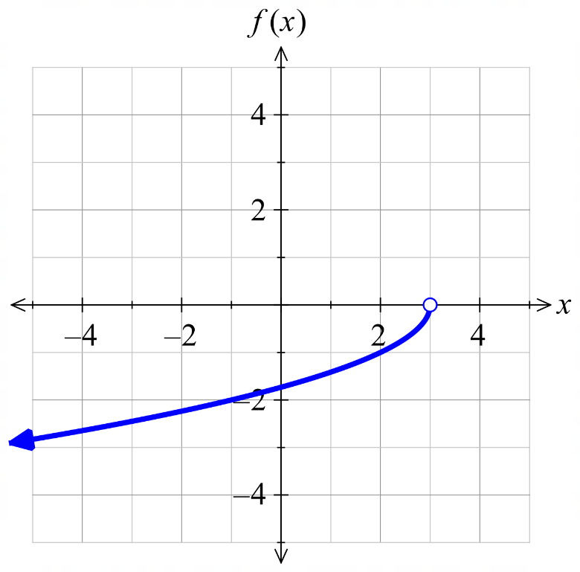
We can combine separate intervals of a domain with the union symbol $∪$.
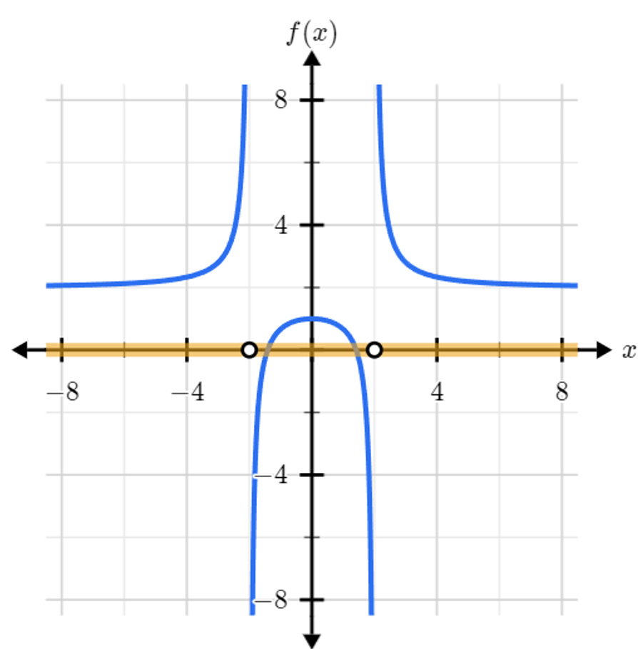
What is the domain of the graphed function?
- $\left(-∞,-2\right) ∪ \left(-2,2\right) ∪ \left(2,∞\right)$
- $\left(-∞,-2\right] ∪ \left[-2,2\right] ∪ \left[2,∞\right)$
- $[-∞,-2] ∪ \left(-2,2\right) ∪ (2,∞]$

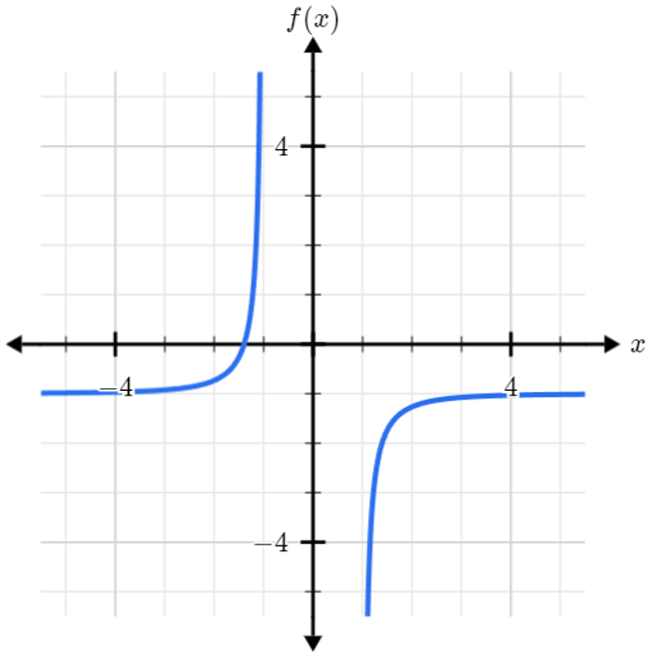
What is the domain of the graphed function?

- Investigation Range
The range is the possible outputs of a function.
We can specify a range with an interval, and we can visualise it as a shadow on the $y$-axis.
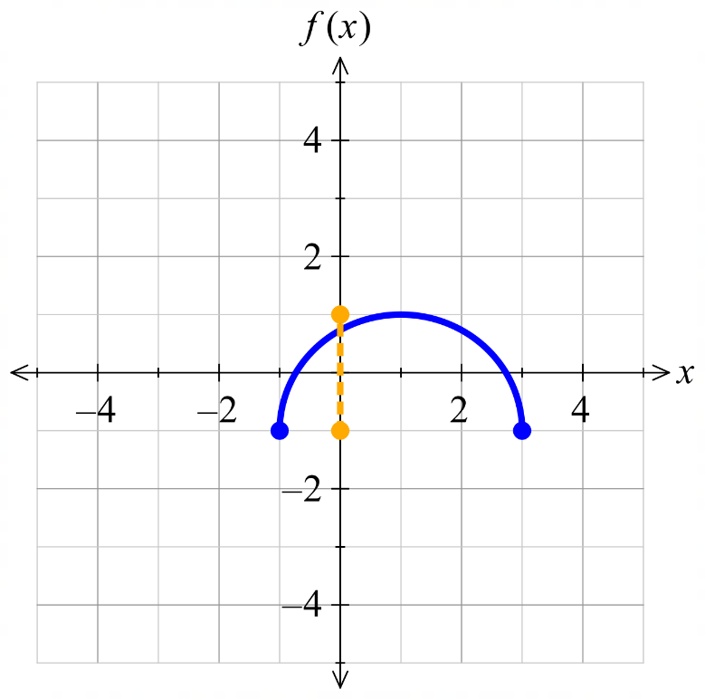  The range is $\left[-1,1\right]$ | 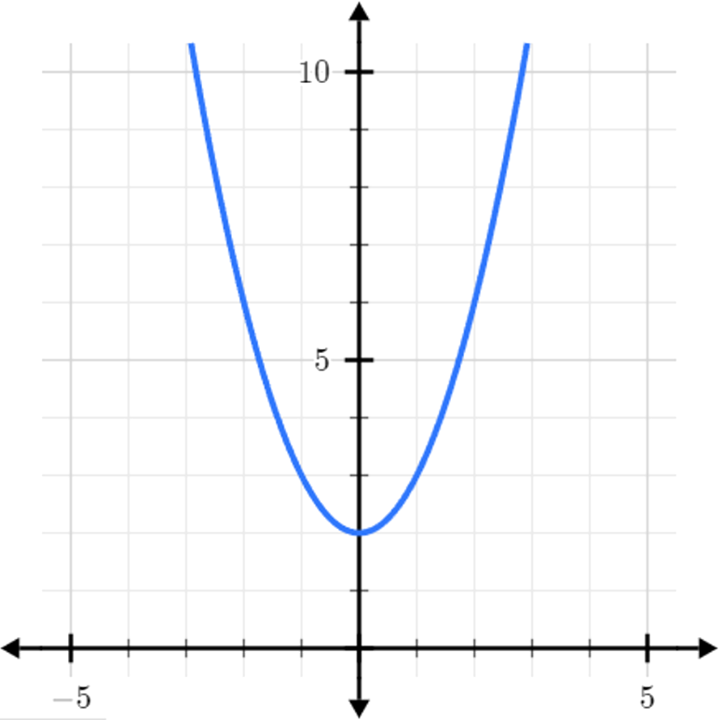  The range is …………
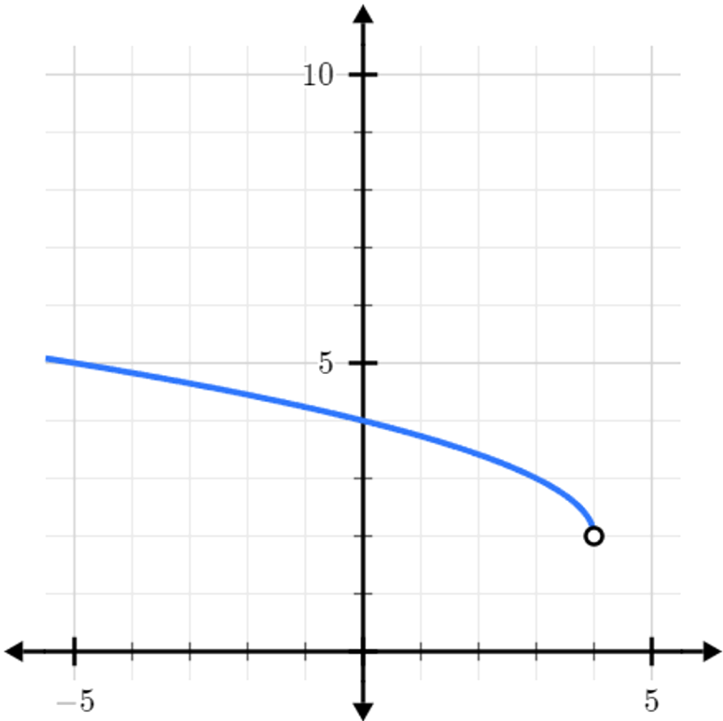  The range is ………… | 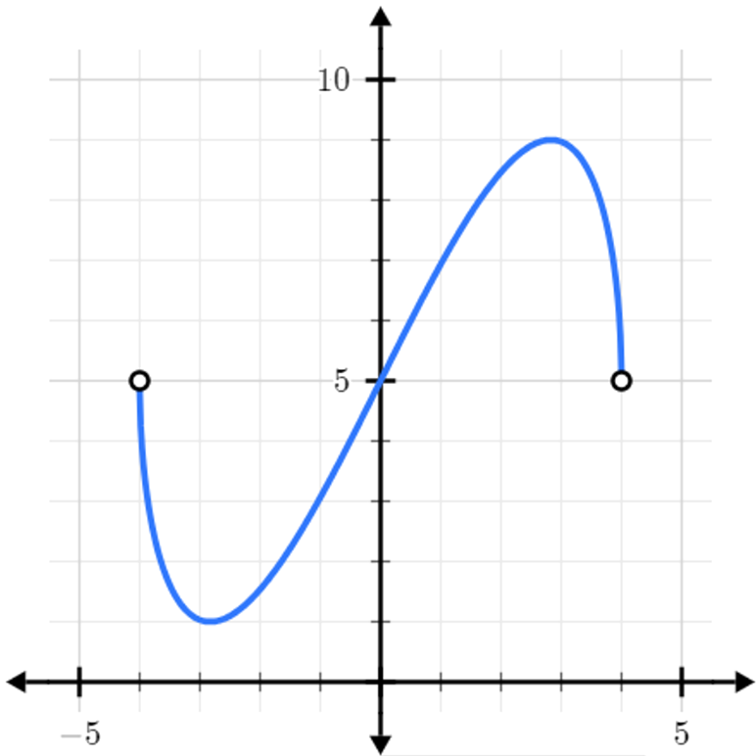  The range is …………
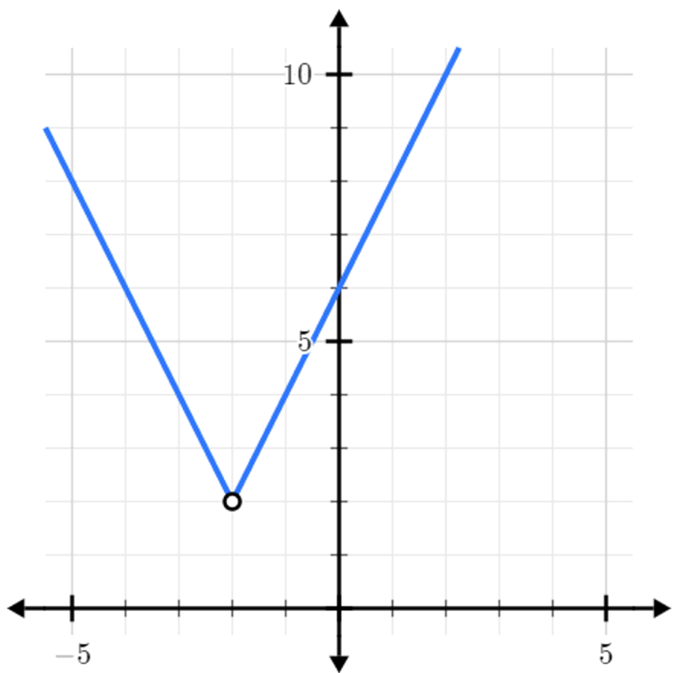  The range is ………… | 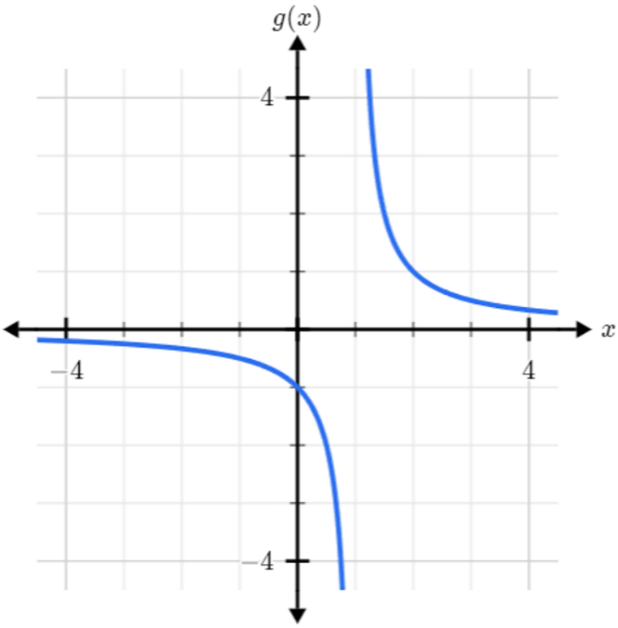  The range is …………
- Domain and Range of a Function
The domain of a function is the set of all allowable $x$-values.  Visualise it as a shadow on the $x$-axis. | The range of a function is the set of all possible $y$-values.  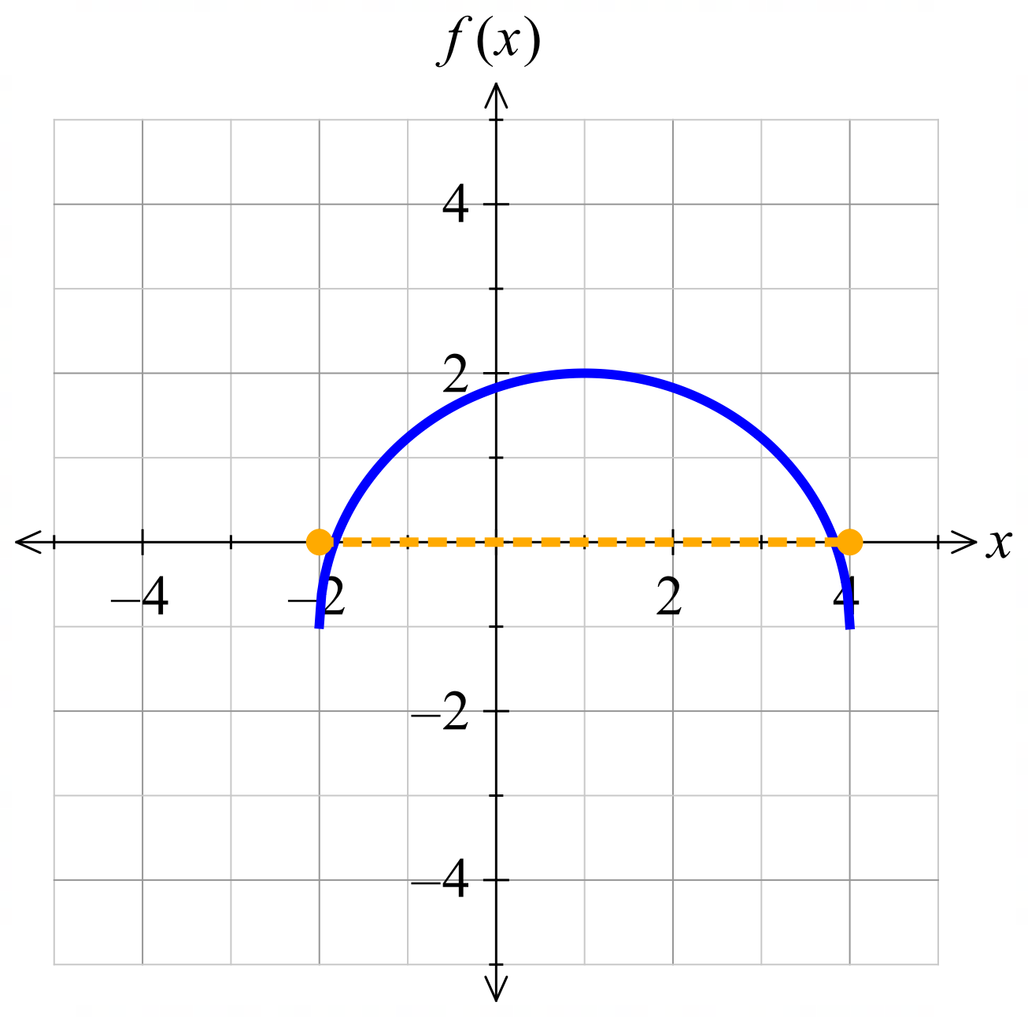  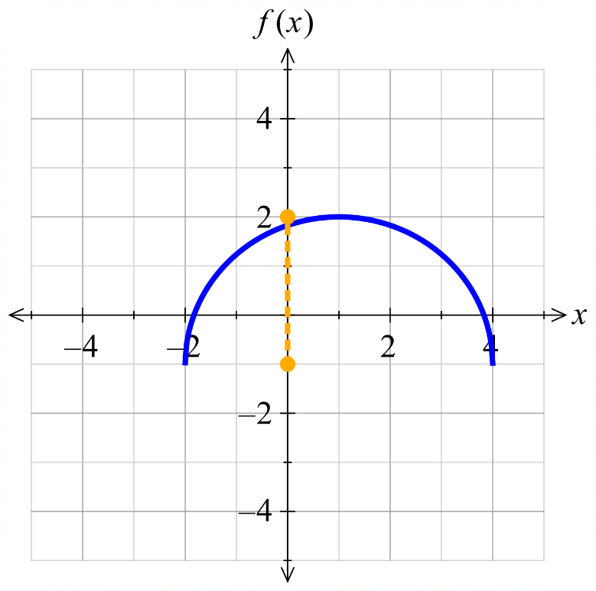  Visualise it as a shadow on the $y$-axis.

- Example Identify domain and range from a graph
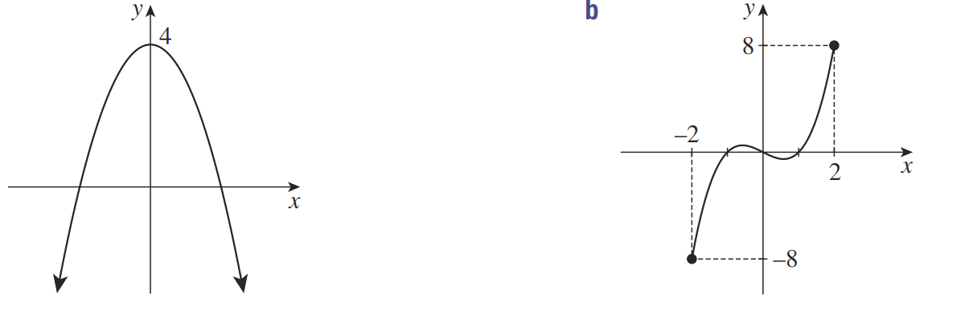  Domain: $-2≤x≤2$ $[-2,2]$  Range: $-8≤y≤8$ $\left[-8,8\right]$ | Domain: all real $x$ $x∈R$  Range: $y≤4$ $\left(-∞, 4\right]$

- Guided Practice
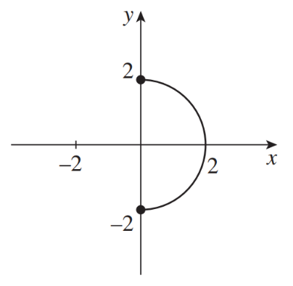  Domain:  $$0≤x≤2 [0,2]$$  Range:  $$-2≤y≤2 \left[-2,2\right]$$ | 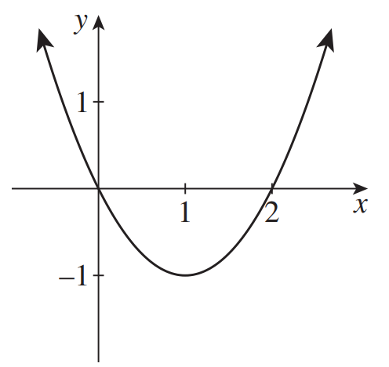  Domain:  all real $x x∈R$  Range:  $$y≥-1 \left[-1,∞\right)$$

Foundation
- Identify the domain and range of these graphs.
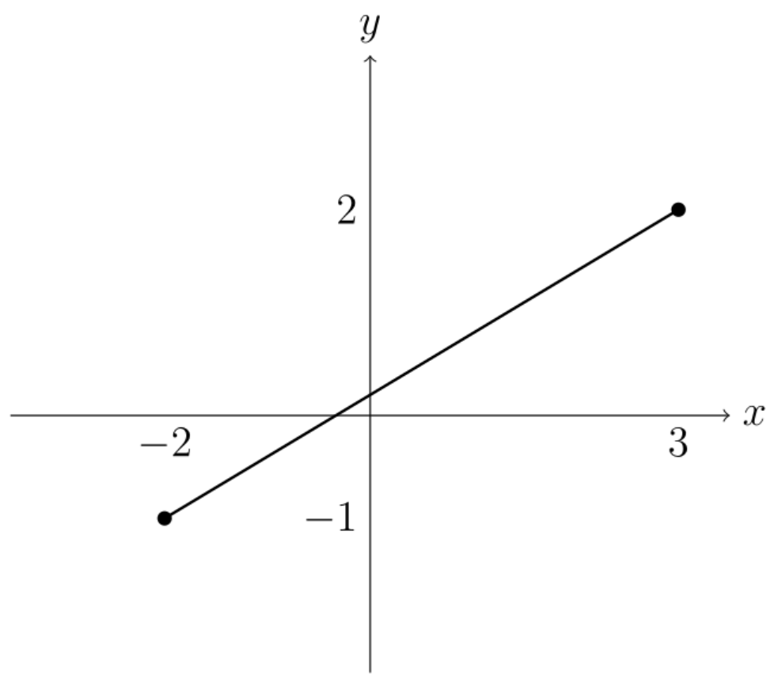  Domain:  Range: | 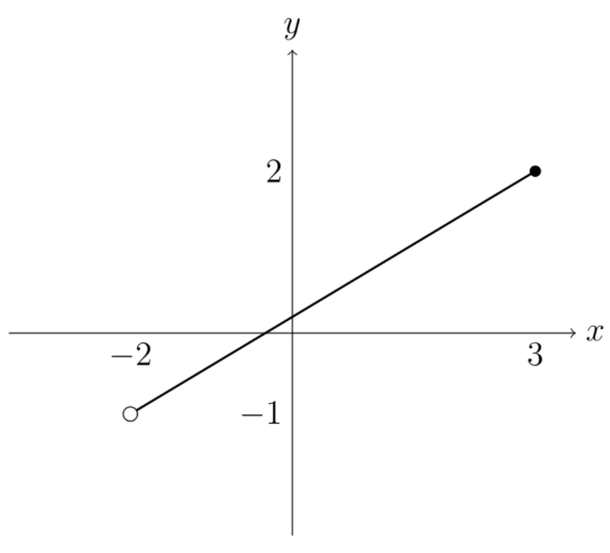  Domain:  Range: | 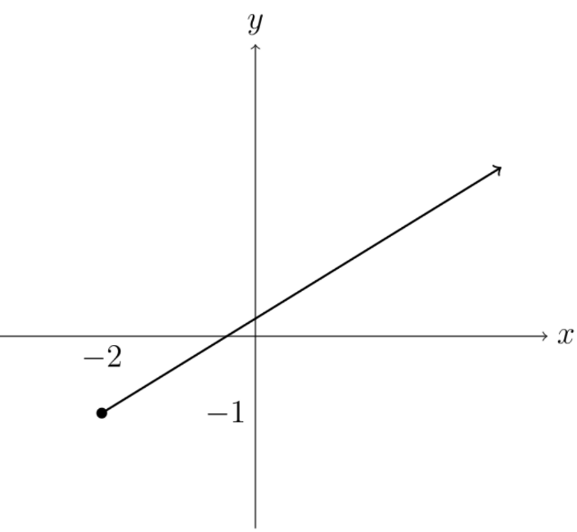  Domain:  Range:
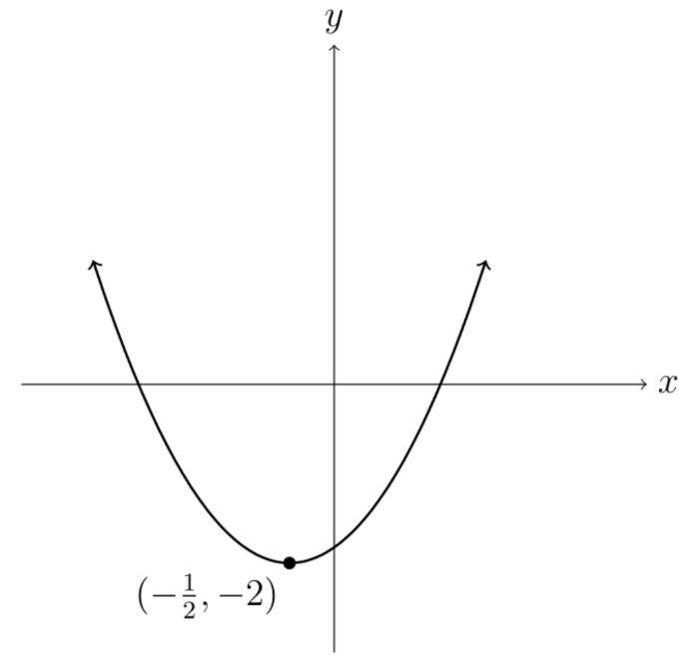  Domain:  Range: | 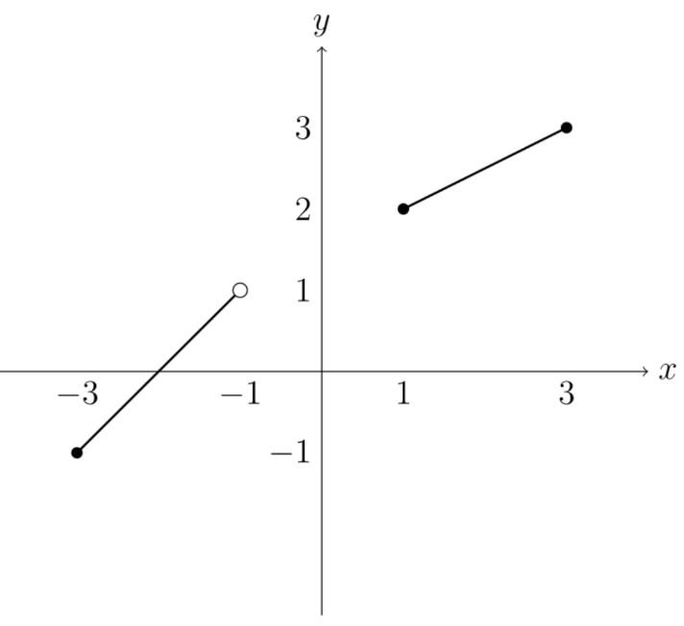  Domain:  Range: | 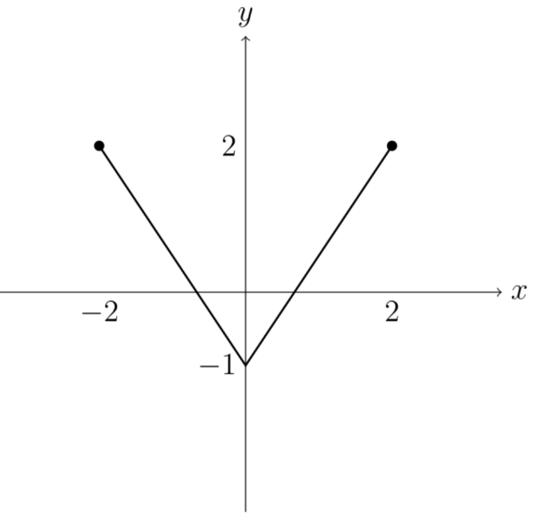  Domain:  Range:
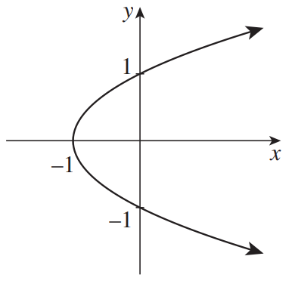  Domain: $\left[-1,∞\right)$  Range: $y∈R$ | 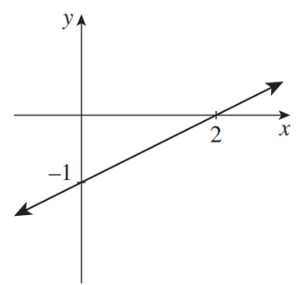  Domain: $x∈R$  Range: $y∈R$ | 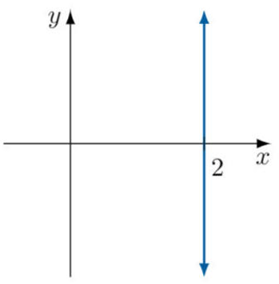  Domain: $x=2$  Range: $y∈R$
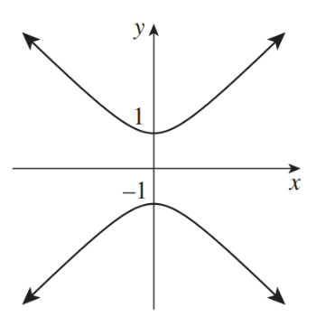  Domain: $x∈R$  Range: $\left(-∞,-1\right]∪\left[1,∞\right)$ | 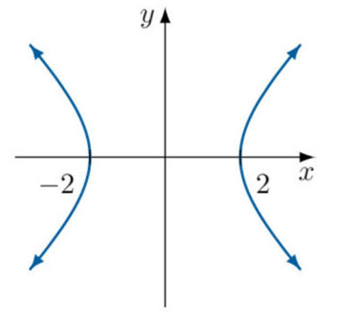  Domain: $\left(-∞,-2\right]∪\left[2,∞\right)$  Range: $y∈R$ | 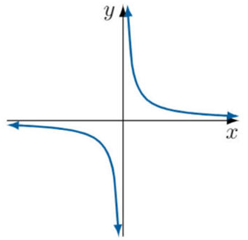  Domain: $\left(-∞, 0\right)∪\left(0,∞\right)$  Range: $\left(-∞, 0\right)∪\left(0,∞\right)$
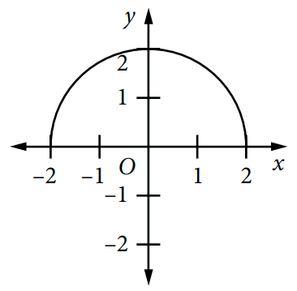  Domain: $\left[-2,2\right]$  Range: $\left[0.,2\right]$ | 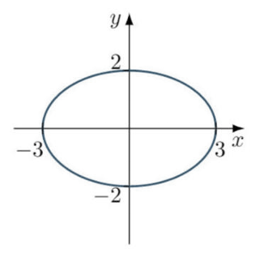  Domain: $\left[-3,3\right]$  Range: $\left[-2.,2\right]$ | 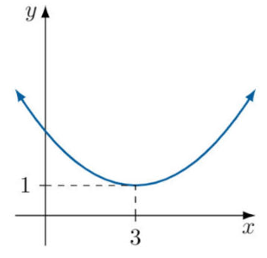  Domain: $x∈R$  Range: $\left[1,∞\right)$
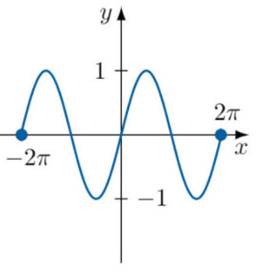  Domain: $\left[-2π,2π\right]$  Range: $\left[-1,1\right]$ | 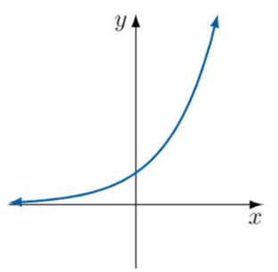  Domain: $x∈R$  Range: $\left(0,∞\right)$ | 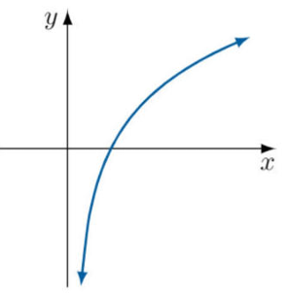  Domain: $\left(0,∞\right)$  Range: $y∈R$
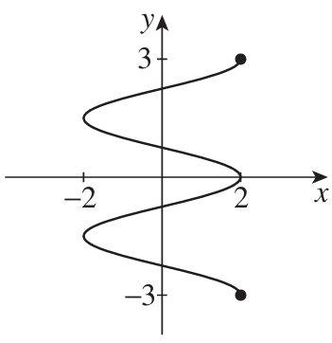  Domain: $\left[-2,2\right]$  Range: $\left[-3,3\right]$ | 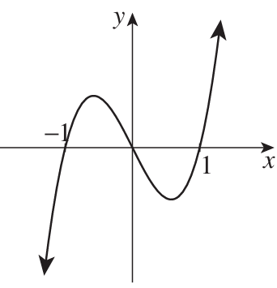  Domain: $x∈R$  Range: $y∈R$ | 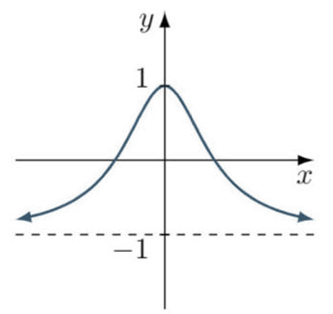  Domain: $x∈R$  Range: $\left(-1,1\right]$

Natural Domain and Range

- Natural Domain
A function's natural domain includes all possible $x$-values that produce valid $y$-values.
Many functions have no restriction on their domain, but some do.
When finding the natural domain, consider that
- Zero denominators are undefined.
- Numbers in square roots must be non-negative.

- Example Find the natural domain of a function
Find the natural domain of:  $$y=\frac{1}{x-2}$$  $$x-2≠0 \\ x≠2$$  Domain: all real numbers except $x=2$ $\left(-∞,2\right)∪\left(2,∞\right)$ | Find the natural domain of:  $$y=\sqrt{x-1}$$  $$x-1≥0$$  $$x≥1$$Domain: $x≥1$ $\left[1,∞\right)$

- Guided Practice
Find the natural domain of each function.
- $y=x^{2}$  all real $x x∈R$ | - $f\left(x\right)=\sqrt{x-5}$  $$x≥5 \left[5,∞\right)$$
- $f(x)=$ $\frac{1}{3x}$  all real $x$ except $x=0$ $\left(-∞,0\right)∪\left(0,∞\right)$ | - $y=$ $\frac{1}{\sqrt{3-x}}$  $$x<3 \left(-∞,3\right)$$

- Natural Range
The natural range is most easily found from sketching the graph.
To find it algebraically, consider that:
$$\sqrt{expression}≥0, {\left(expression\right)}^{2}≥0, \frac{1}{expression}≠0$$

Foundation
- Identify the natural domain of these functions.
- $f\left(x\right)=\sqrt{x}$  $$x≥0$$ | - $f\left(x\right)=\sqrt{x-2}$  $$x≥2$$ | - $f\left(x\right)=\sqrt{x+2}$  $$x≥-2$$
- $f\left(x\right)=\sqrt{5-x}$  $$x≤5$$ | - $f\left(x\right)=\sqrt{7-2x}$  $$x≤\frac{7}{2}$$ | - $f\left(x\right)=\sqrt{2+5x}+1$  $$x≥-\frac{2}{5}$$

- Identify the natural domain of these functions.
- $f\left(x\right)=$ $\frac{1}{x}$  $$x≠0$$ | - $f\left(x\right)=$ $\frac{1}{x-2}$  $$x≠2$$ | - $f\left(x\right)=$ $\frac{1}{x+3}$  $$x≠-3$$
- $f\left(x\right)=$ $\frac{1}{2x-3}$  $$x≠\frac{3}{2}$$ | - $f\left(x\right)=$ $\frac{x}{x+2}$  $$x≠-2$$ | - $f\left(x\right)=$ $\frac{2}{x-7}$ $+3$  $$x≠7$$

- Recall that the range of $f\left(x\right)=x^{2}$ is $y≥0$ because $x^{2}$ cannot be negative.
Use this, or your knowledge of the graph, to determine the range of:
- $f\left(x\right)=4x^{2}$  $$y≥0$$ | - $f\left(x\right)=x^{2}+3$  $$y≥3$$ | - $f\left(x\right)=3x^{2}-4$  $$y≥-4$$
- $f\left(x\right)=-x^{2}$  $$y≤0$$ | - $f\left(x\right)=-x^{2}+6$  $$y≤6$$ | - $f\left(x\right)=5-x^{2}$  $$y≤5$$
- $f\left(x\right)=3-4x^{2}$  $$y≤3$$ | - $f\left(x\right)={\left(x-3\right)}^{2}+2$  $$y≥2$$ | - $f\left(x\right)=10-{\left(x+2\right)}^{2}$  $$y≤10$$
- Find the natural domain of these functions.
- $f\left(x\right)=4x$  $$x∈R$$ | - $f\left(x\right)=3x$  $$x∈R$$ | - $f\left(x\right)=x$  $$x∈R$$
- $f\left(x\right)=$ $\frac{1}{4x}$  $$x≠0$$ | - $f\left(x\right)=\sqrt{3x}$  $$x≥0$$ | - $f\left(x\right)=$ $\frac{1}{\sqrt{x}}$  $$>0$$
- $f\left(x\right)=$ $\frac{1}{x+4}$  $$x≠-4$$ | - $f\left(x\right)=\sqrt{x+3}$  $$x≥-3$$ | - $f\left(x\right)=$ $\frac{1}{\sqrt{5x}}$  $$x>0$$
- $f\left(x\right)=$ $\frac{1}{-x+4}$  $$x≠4$$ | - $f\left(x\right)=\sqrt{-x+3}$  $$x≤3$$ | - $f\left(x\right)=$ $\frac{1}{\sqrt{5x+1}}$  $$x>-\frac{1}{5}$$
- $f\left(x\right)=$ $\frac{1}{x-4}$  $$x≠4$$ | - $f\left(x\right)=\sqrt{x-3}$  $$x≥3$$ | - $f\left(x\right)=$ $\frac{2}{\sqrt{5x+1}}$  $$x>-\frac{1}{5}$$
- $f\left(x\right)=$ $\frac{1}{6x-4}$  $$x≠\frac{2}{3}$$ | - $f\left(x\right)=\sqrt{8x-3}$  $$x≥\frac{3}{8}$$ | - $f\left(x\right)=$ $\frac{2}{\sqrt{5x-1}}$  $$x>\frac{1}{5}$$
- $f\left(x\right)=$ $\frac{3}{6x-4}$  $$x≠\frac{2}{3}$$ | - $f\left(x\right)=5\sqrt{8x-3}$  $$x≥\frac{3}{8}$$ | - $f\left(x\right)=$ $\frac{2}{\sqrt{1-5x}}$  $$x<\frac{1}{5}$$
- $f\left(x\right)=-$ $\frac{3}{6x-4}$  $$x≠\frac{2}{3}$$ | - $f\left(x\right)=-5\sqrt{8x-3}$  $$x≥\frac{3}{8}$$ | - $f\left(x\right)=-$ $\frac{2}{\sqrt{1-5x}}$  $$x<\frac{1}{5}$$

Development
- Recall that the range of $f\left(x\right)=\sqrt{x}$ is $y≥0$ because $\sqrt{x}$ cannot be negative.
Use this to determine the range of:
- $f\left(x\right)=2\sqrt{x}$  $$y≥0$$ | - $f\left(x\right)=\sqrt{x}+3$  $$y≥3$$ | - $f\left(x\right)=\sqrt{x}-5$  $$y≥-5$$
- $f\left(x\right)=-\sqrt{x}$  $$y≤0$$ | - $f\left(x\right)=-\sqrt{x}+4$  $$y≤4$$ | - $f\left(x\right)=3-\sqrt{x}$  $$y≤3$$

- Identify the natural domain of these functions.
- $f\left(x\right)=$ $\frac{2}{\sqrt{1-x}}$  $$x<1$$ | - $f\left(x\right)=$ $\frac{1}{\sqrt{2x-3}}$  $$x>\frac{3}{2}$$ | - $f\left(x\right)=$ $\frac{x}{\sqrt{x+2}}$  $$x>-2$$
- $f\left(x\right)=$ $\frac{1}{x^{2}-4}$  $x≠2$ and $x≠-2$ | - $f\left(x\right)=$ $\frac{1}{x^{2}+x}$  $x≠0$ and $x≠-1$ | - $f\left(x\right)=$ $\frac{1}{x^{2}-5x+6}$  $x≠2$ and $x≠3$

- Using graphing software, or otherwise, sketch $f\left(x\right)={\left(x-2\right)}^{2}+1$.
  - State the range of $f\left(x\right)$.
$$y≥1$$
  - Similarly, find the range of:
- $f\left(x\right)={\left(x+1\right)}^{2}-4$  $$y≥-4$$ | - $f\left(x\right)={\left(x-2\right)}^{2}+3$  $$y≥3$$
- $f\left(x\right)={\left(x-2\right)}^{2}-5$  $$y≥-5$$ | - $f\left(x\right)=x^{2}+6x+11$  $$y≥2$$

  - What do you notice about the range of the function $f\left(x\right)={\left(x-a\right)}^{2}+k$? Why is this?

The range is $y≥k$
This is because the coordinate $y=k$ is part of the minimum turning point of the concave up parabola

- State the range, start with $\sqrt{expression}≥0$.
- $f(x)=\sqrt{x}$  $$y≥0$$ | - $f(x)=\sqrt{x}+3$  $$y≥3$$ | - $f(x)=\sqrt{x-4}+3$  $$y≥3$$
- $f(x)=2\sqrt{x-4}+3$  $$y≥3$$ | - $f(x)=5-\sqrt{x-4}$  $$y≤5$$ | - $f(x)=5-2\sqrt{x-4}$  $$y≤5$$

- State the range, start with $x^{2}≥0$.
- $f(x)=x^{2}$  $$y≥0$$ | - $f(x)=x^{2}+4$  $$y≥4$$ | - $f(x)=3x^{2}+4$  $$y≥4$$
- $f(x)=4-3x^{2}$  $$y≤4$$ | - $f(x)=4-3(x-2)^{2}$  $$y≤4$$ | - $f(x)=-2(x+1)^{2}-3$  $$y≤-3$$

- State the range, start with the fact that a non-zero reciprocal term cannot equal zero $\frac{1}{x}≠0$.
- $f(x)=\frac{1}{x}$  $$y≠0$$ | - $f(x)=\frac{1}{x}+2$  $$y≠2$$ | - $f(x)=\frac{4}{x}+2$  $$y≠2$$
- $f(x)=\frac{4}{x}-3$  $$y≠-3$$ | - $f(x)=\frac{4}{x-1}-3$  $$y≠-3$$ | - $f(x)=5-\frac{2}{x+4}$  $$y≠5$$

- State the range of these functions, using $x^{2}≥0, \sqrt{x}≥0, \frac{1}{x}≠0$
- $f(x)=7-x^{2}$  $$y≤7$$ | - $f(x)=\sqrt{x+6}-4$  $$y≥-4$$ | - $f(x)=\frac{3}{x-2}+5$  $$y≠5$$
- $f(x)=2(x+1)^{2}-6$  $$y≥-6$$ | - $f(x)=8-\sqrt{3x-1}$  $$y≤8$$ | - $f\left(x\right)=\frac{3}{x-2}-4$  $$y≠-4$$

- State the natural domain of these functions.
- $f(x)=$ $\frac{\sqrt{x}}{x-2}$  $$[0,2)∪(2,∞)$$ | - $f(x)=$ $\frac{\sqrt{x+1}}{x-2}$  $$[-1,2)∪(2,∞)$$
- $f(x)=\sqrt{x+1}+\sqrt{5-x}$  $[-1,5$] | - $f(x)=\sqrt{x+1}+\sqrt{3-x}$  $$[-1,3]$$
- $f(x)=$ $\frac{1}{\sqrt{x+1}}$  $$x>-1$$ | - $f(x)=$ $\frac{1}{\sqrt{3-x}}$  $$x<3$$
- $f(x)=\sqrt{x+1}+$ $\frac{1}{\sqrt{5-x}}$  $$[-1,5)$$ | - $f(x)=\sqrt{x+4}+$ $\frac{1}{x-1}$  $$[-4,1)∪(1,∞)$$
- $f(x)=$ $\frac{\sqrt{x+3}}{x-1}$  $$[-3,1)∪(1,∞)$$ | - $f(x)=$ $\frac{\sqrt{x+3}}{x+1}$  $$[-3,-1)∪(-1,∞)$$
- $f(x)=$ $\frac{\sqrt{5-x}}{x+1}$  $$(-∞,-1)∪(-1,5]$$ | - $f(x)=$ $\frac{\sqrt{5-x}}{x-6}$  $$(-∞,5]$$

  - Determine the range of $y=9-x^{2}$ and hence find the maximum value of $y$.

Range $y≤9$, so max value: $y=9$
  - Hence, find the range of $f\left(x\right)=\sqrt{9-x^{2}}$

$$0≤y≤3$$
  - Use a similar technique to find the range of $y=\sqrt{4-x^{2}}$

$$0≤y≤2$$
  - Hence determine the range of $y=$ $\frac{1}{\sqrt{4-x^{2}}}$

Since $0≤\sqrt{4-x^{2}}≤2$,
Then $\frac{1}{\sqrt{4-x^{2}}}$ $≥$ $\frac{1}{2}$
(need to reverse inequality when reciprocating)
  - By considering the minimum value, find the range of $y=\sqrt{9+x^{2}}$

Minimum value of $9+x^{2}$ is 9.
$$y≥3$$
  - Hence find the range of $y=$ $\frac{1}{\sqrt{9+x^{2}}}$

Consider that $3≤\sqrt{9+x^{2}}<∞$,
$$then 0<\frac{1}{\sqrt{9+x^{2}}}≤\frac{1}{3}$$
(need to reverse inequality when reciprocating)

